**Day 1**

**Simple calculator cpp**

#include <iostream>

#include <conio.h>

using namespace std;

void add();

void add ()

{

int a,b;

cout<<"Enter two numbers:";

cin>>a>>b;

cout<<"Addition="<<a+b<<endl;

}

void sub()

{

int a,b;

cout<<"Enter two numbers:";

cin>>a>>b;

cout<<"Difference="<<a-b<<endl;

}

void mul ()

{

int a,b;

cout<<"Enter two numbers:";

cin>>a>>b;

cout<<"Multiplication="<<a*b<<endl;

}

void div ()

{

int a,b;

cout<<"Enter two numbers:";

cin>>a>>b;

cout<<"Division="<<a/b<<endl;

}

main()

{

system("cls");

int a,b, ch, run;

cout << "\n \t \tWelcome to the Basic CPP Calculator\n";

cout << "1. \tAddition\n";

cout << "2. \tSubtraction\n";

cout << "3. \tMultiplication\n";

cout << "4. \tDivision\n";

start:

cout << " \nEnter your choice:";

cin>> ch;

switch (ch)

{

case 1:

{

add();

cout<< "Do you want to continue (0/1)?";

cin>> run;

if (run == 1)

{

goto start;

}

else

break;

}

case 2:

{

sub();

cout<< "Do you want to continue (0/1)?";

cin>> run;

if (run == 1)

{

goto start;

}

else

break;

}

case 3:

{

mul();

cout<< "Do you want to continue (0/1)?";

cin>> run;

if (run == 1)

{

goto start;

}

else

break;

}

case 4:

{

div();

cout<< "Do you want to continue (0/1)?";

cin>> run;

if (run == 1)

{

goto start;

}

else

break;

}

default:

{

break;

}

}

/*cout<<"Sub="<<a-b<<endl;

cout<<"Multi="<<a*b<<endl;

cout<<"Division="<<a/b<<endl;

cout<<"Mod="<<a%b<<endl;

*/

getch();

}

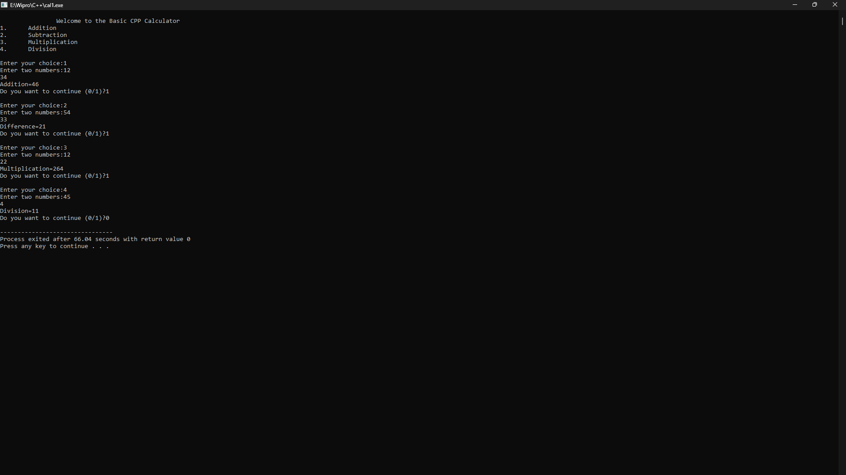

**Day 2**

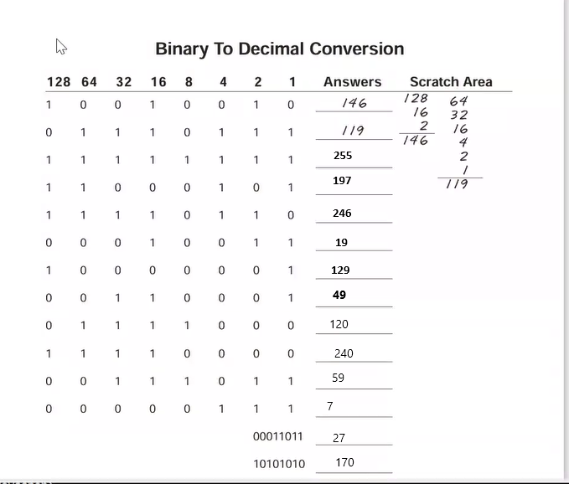

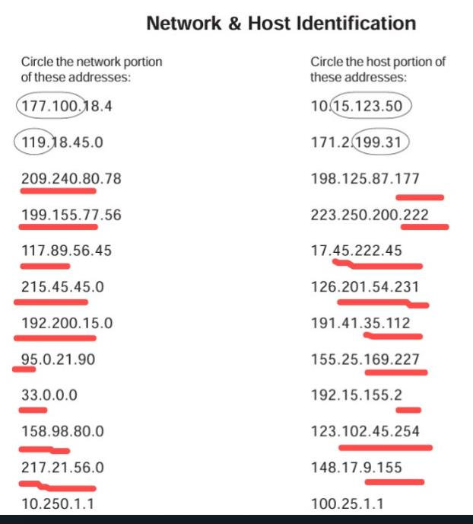

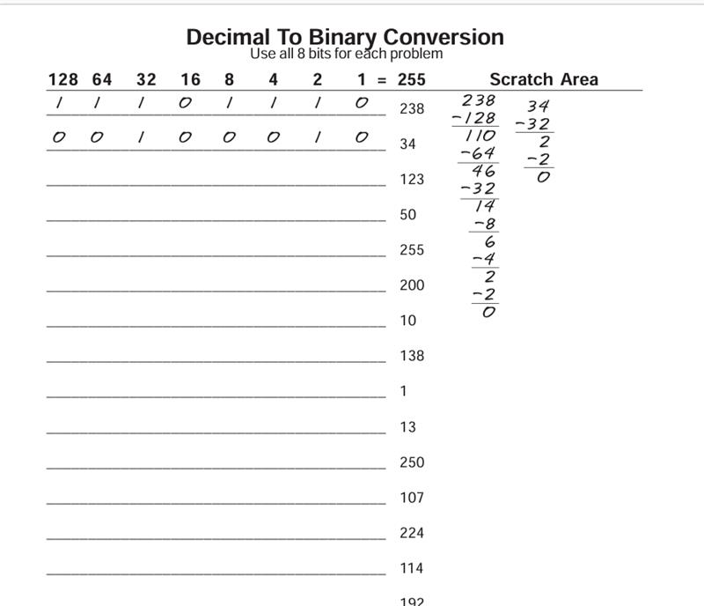

11000000

01110010

11100000

01101011

11111010

00001101

00000001

10001010

00001010

11001000

11111111

00110010

01111011

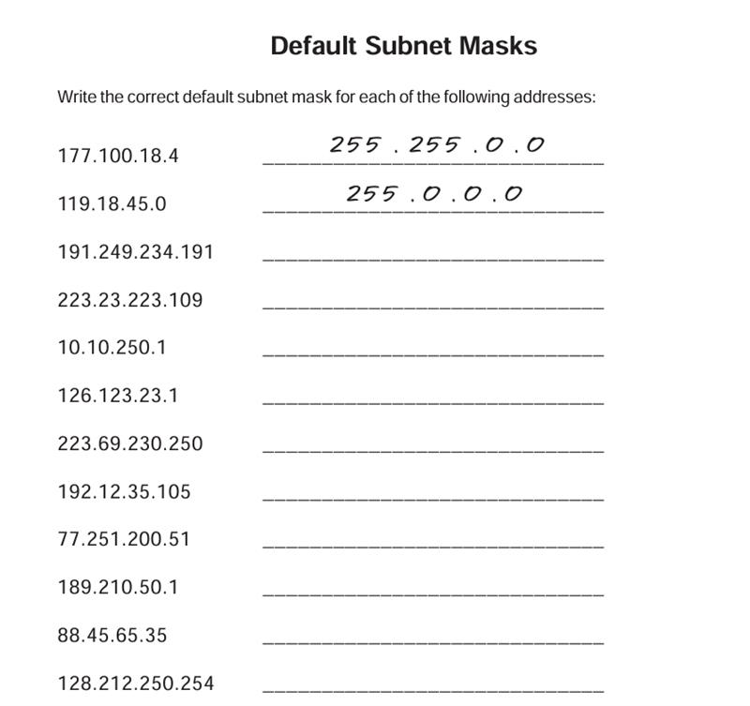

255.0.0.0

255.255.255.0

255.255.0.0

255.0.0.0

255.255.0.0

255.255.255.0

255.0.0.0

255.0.0.0

255.255.255.0

255.255.0.0

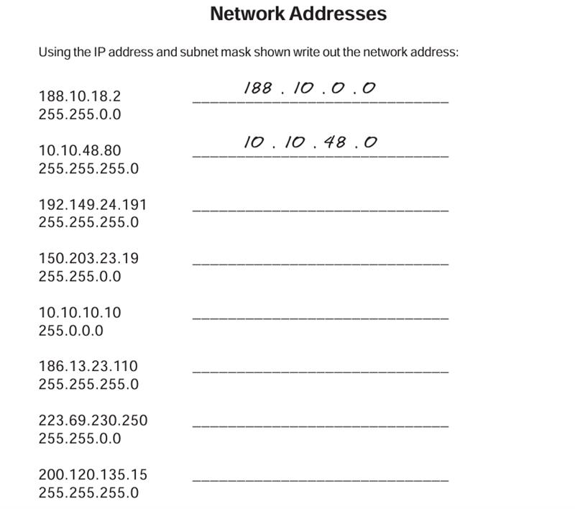

192.149.24.0

150.203.0.0

10.0.0.0

186.13.23.0

223.69.0.0

200.120.135.0

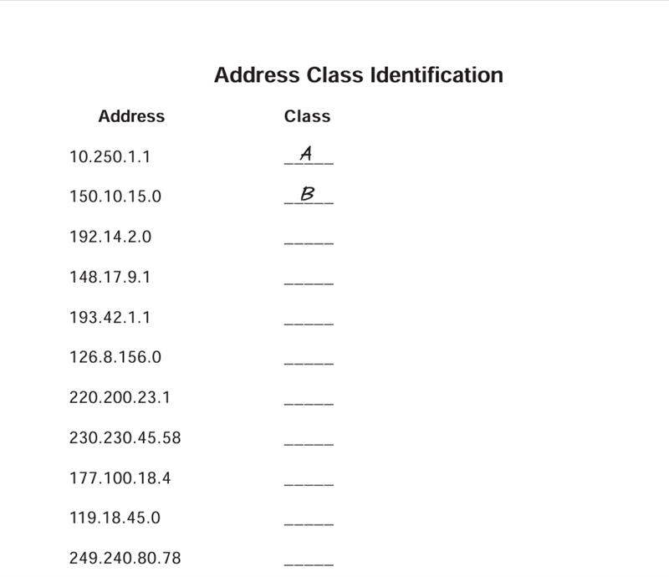

E

A

B

D

C

A

C

B

C

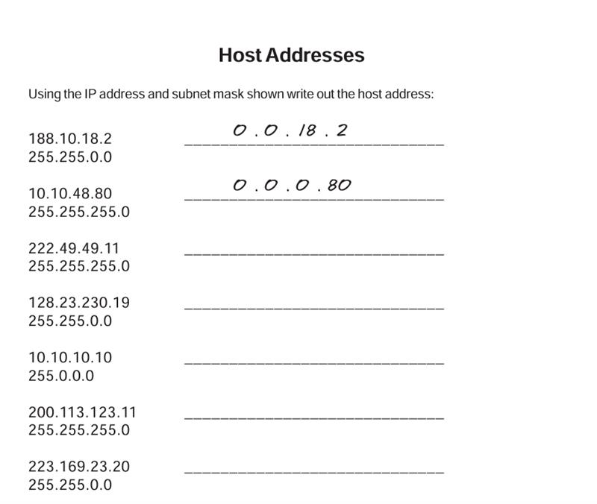

0.0.0.11

0.0.230.19

0.10.10.10

0.0.0.11

0.0.23.20

**Day 3**

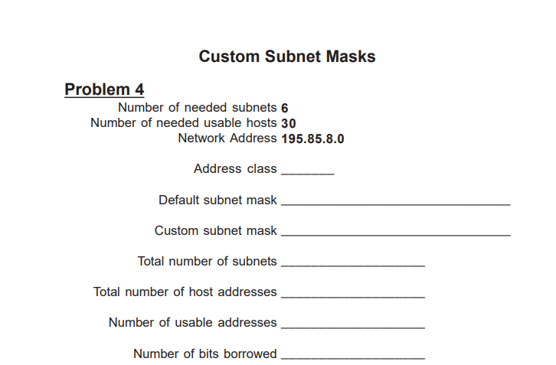

Number of needed subnets-6

Number of needed usable hosts-30

Network Address-195.85.8.0

Address class-C

Default subnet mask->255.255.255.0

Custom subnet mask-->255.255.255.224/27

Total number of subnets-8

Total number of host addresses--> 8 (5 bit for host)

Number of usable addresses-->6

Number of bits borrowed-->3

**Day 4**

Lab 1: Connecting the devices

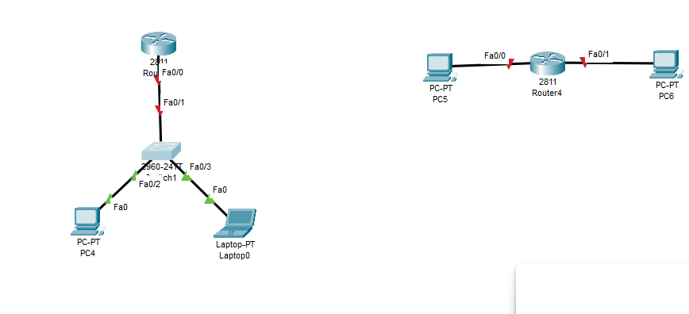

Lab 2: IP address Configuration and Ping check

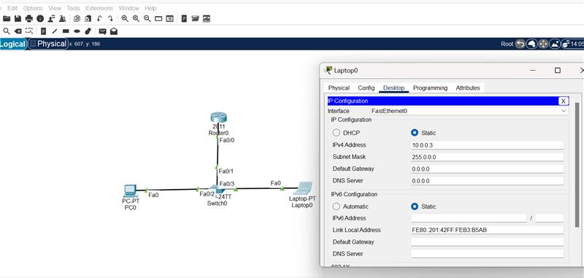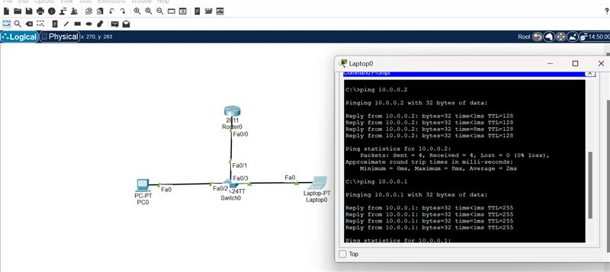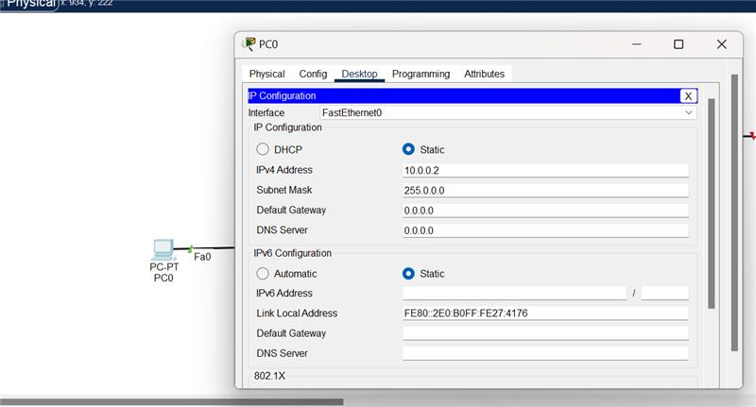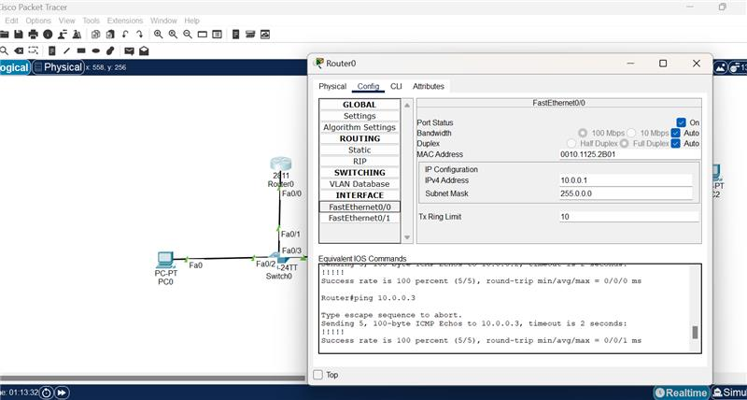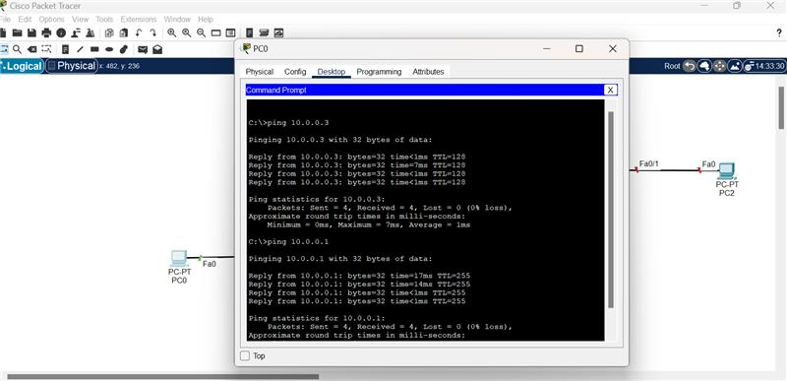

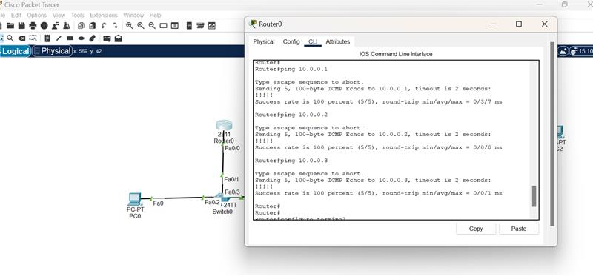

Lab 3: Configuring Default Gateway

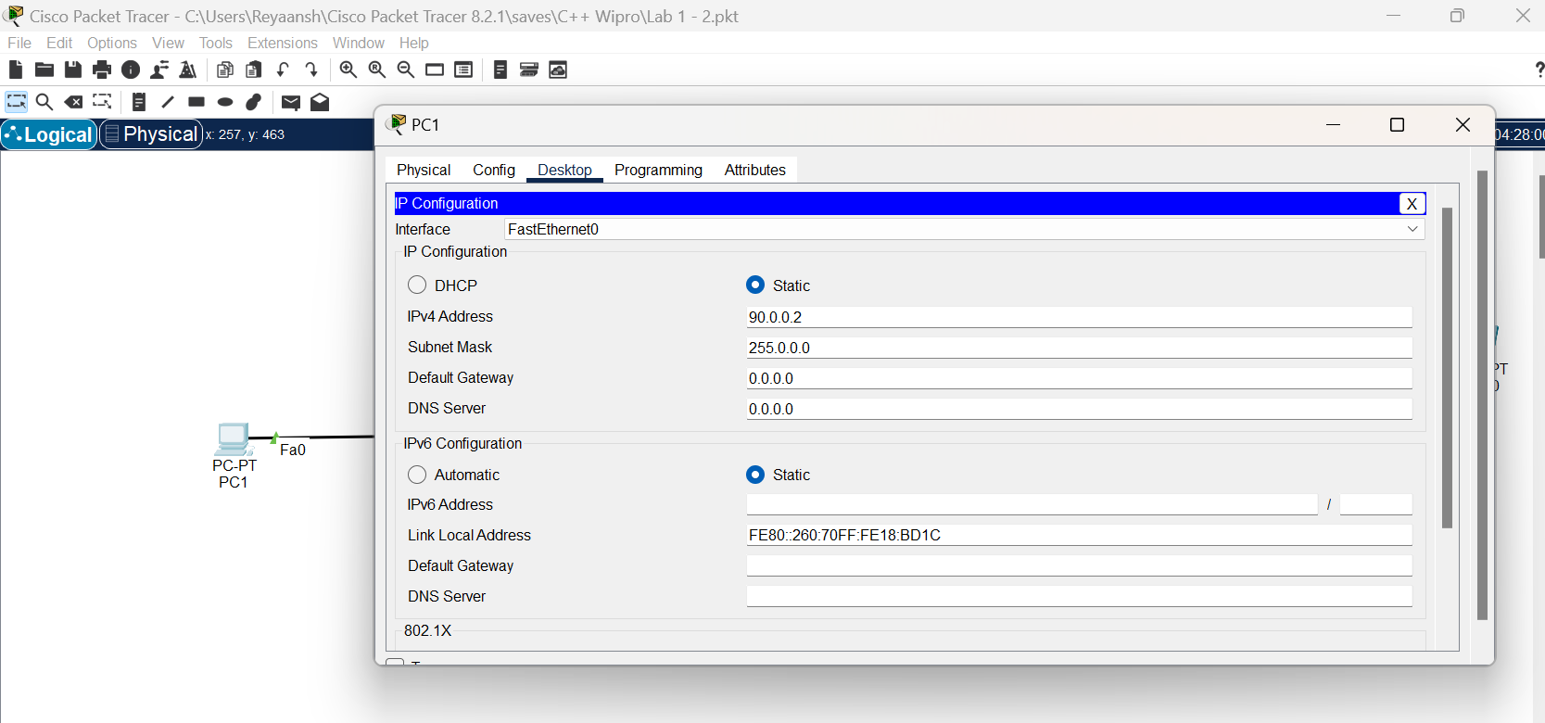



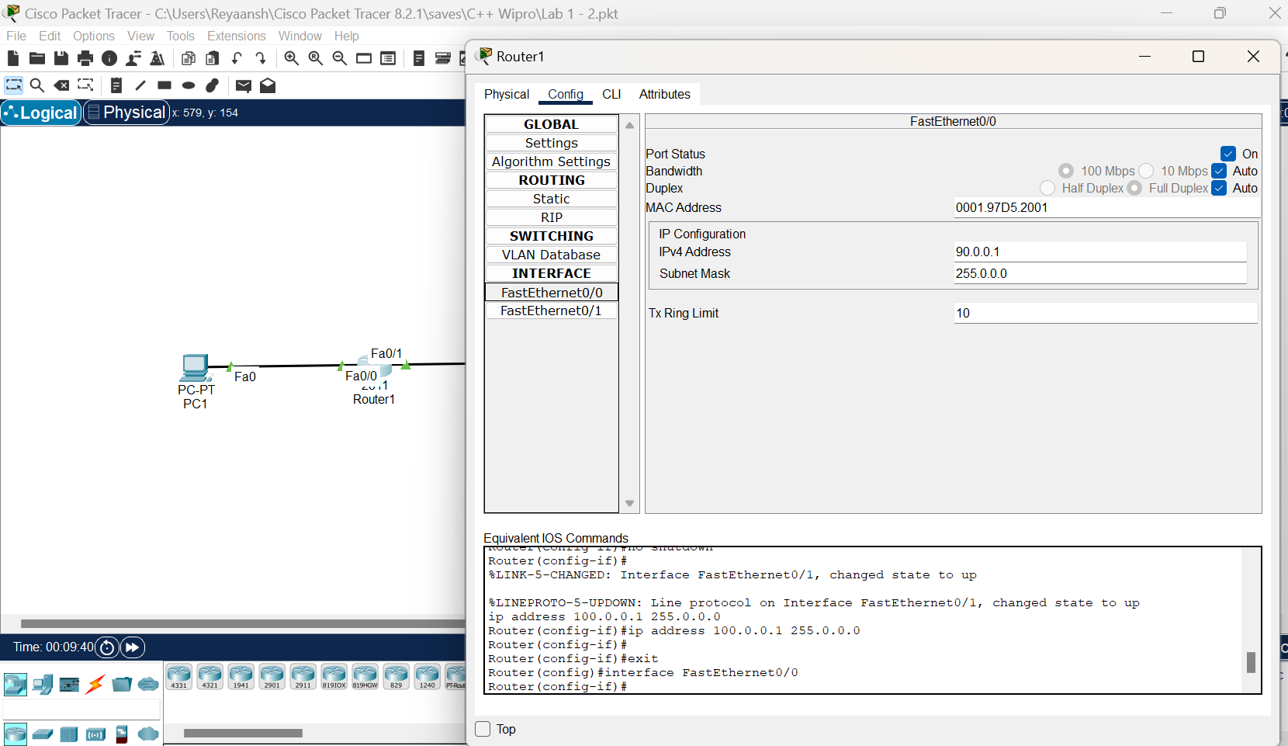



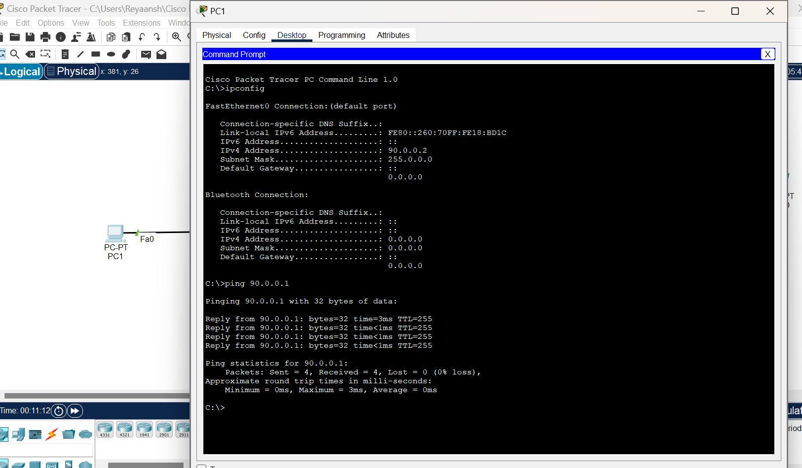

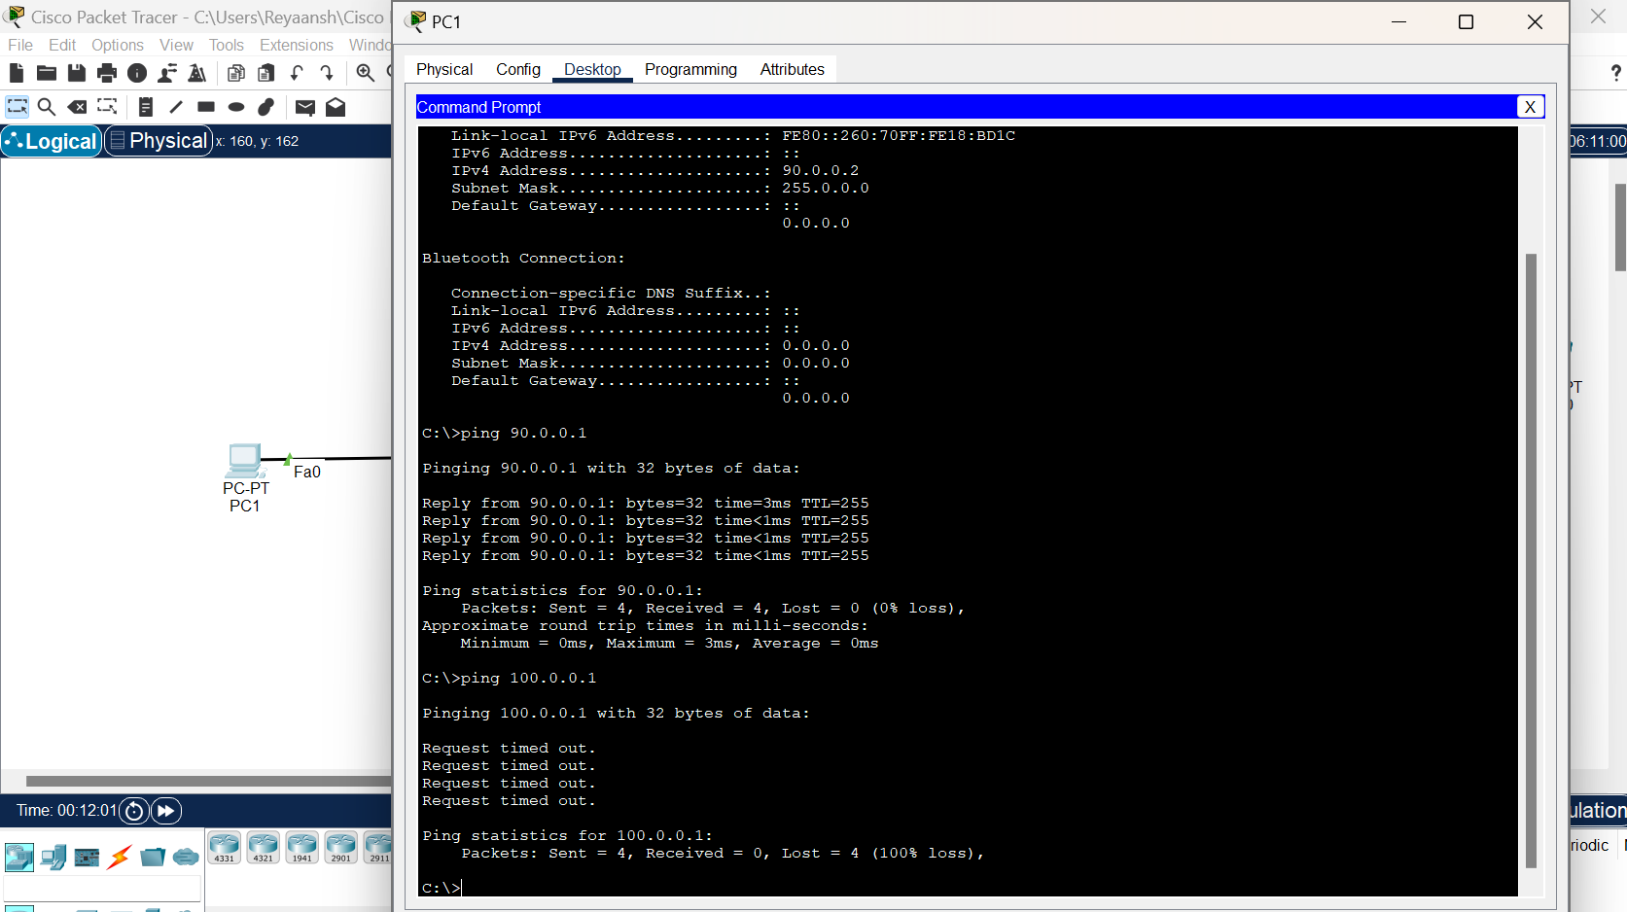

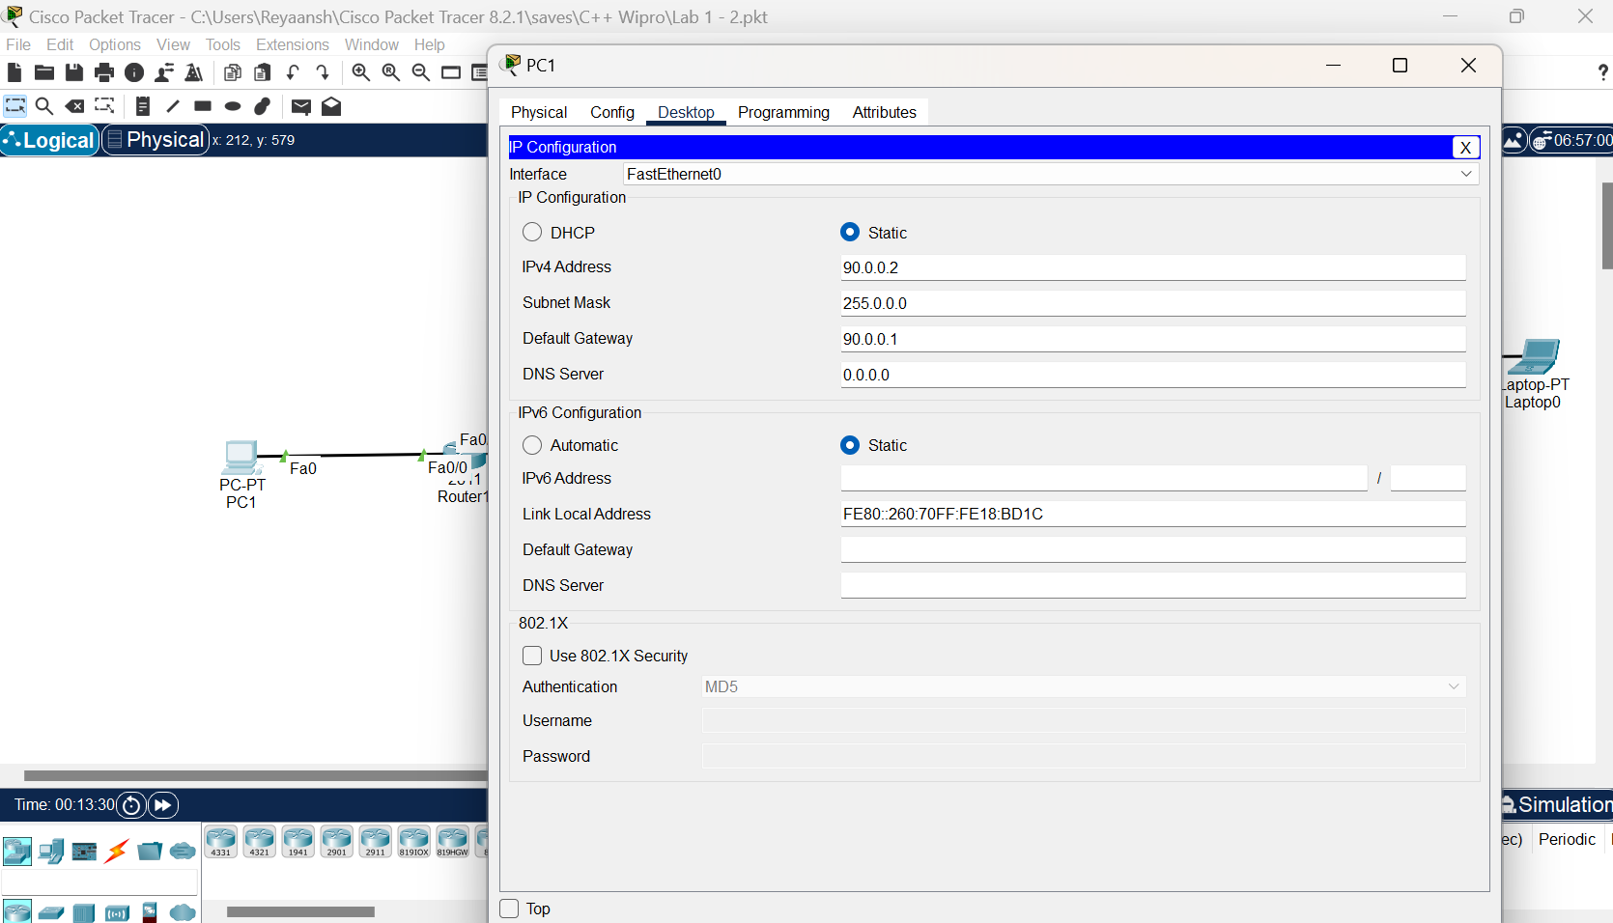



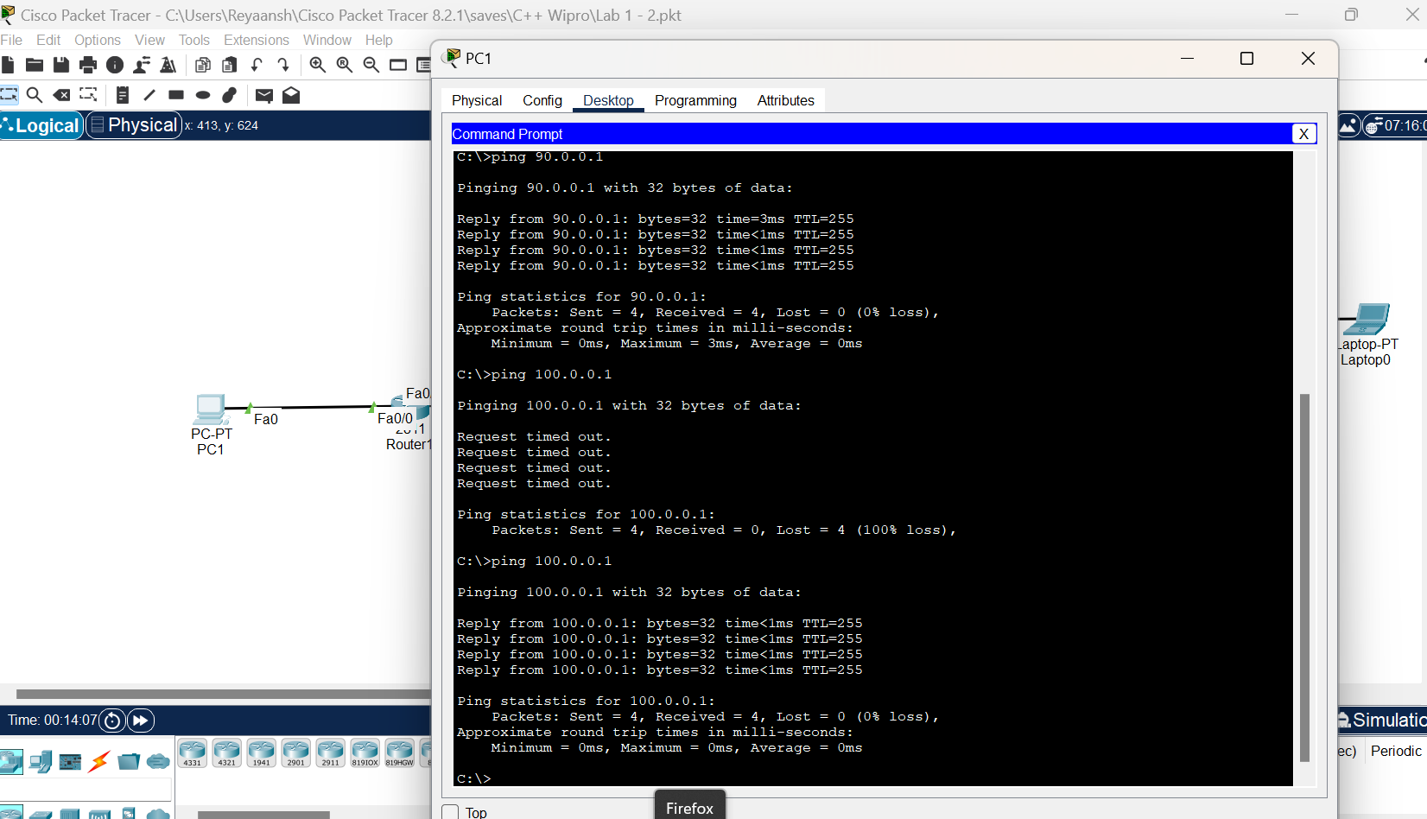

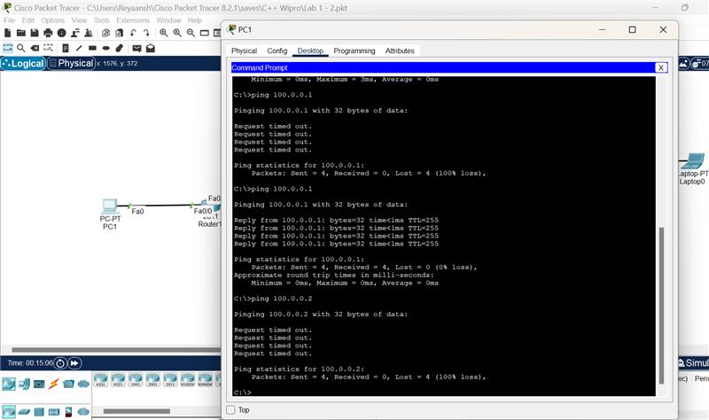

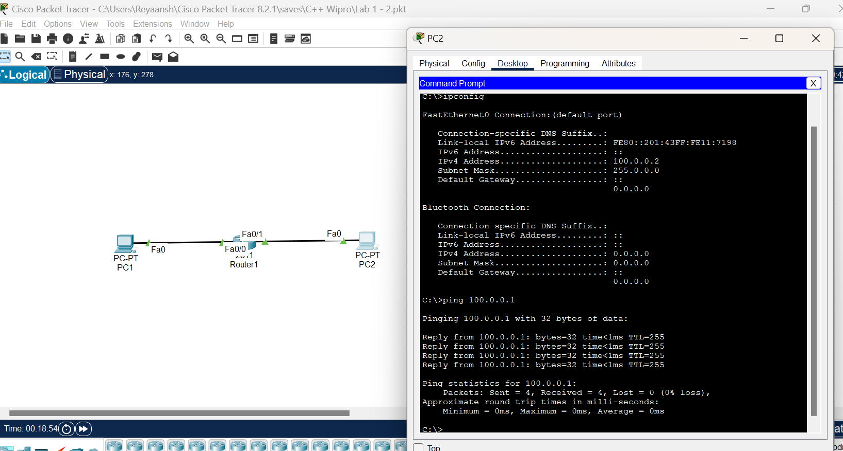

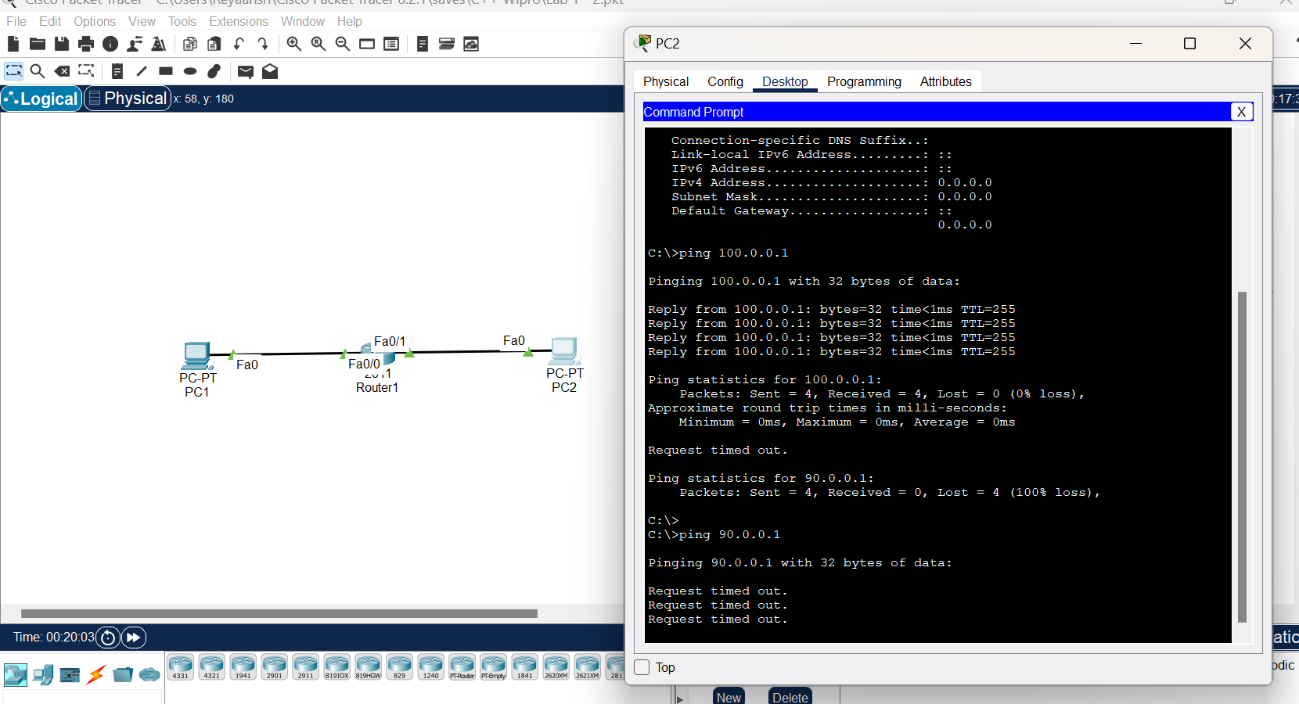

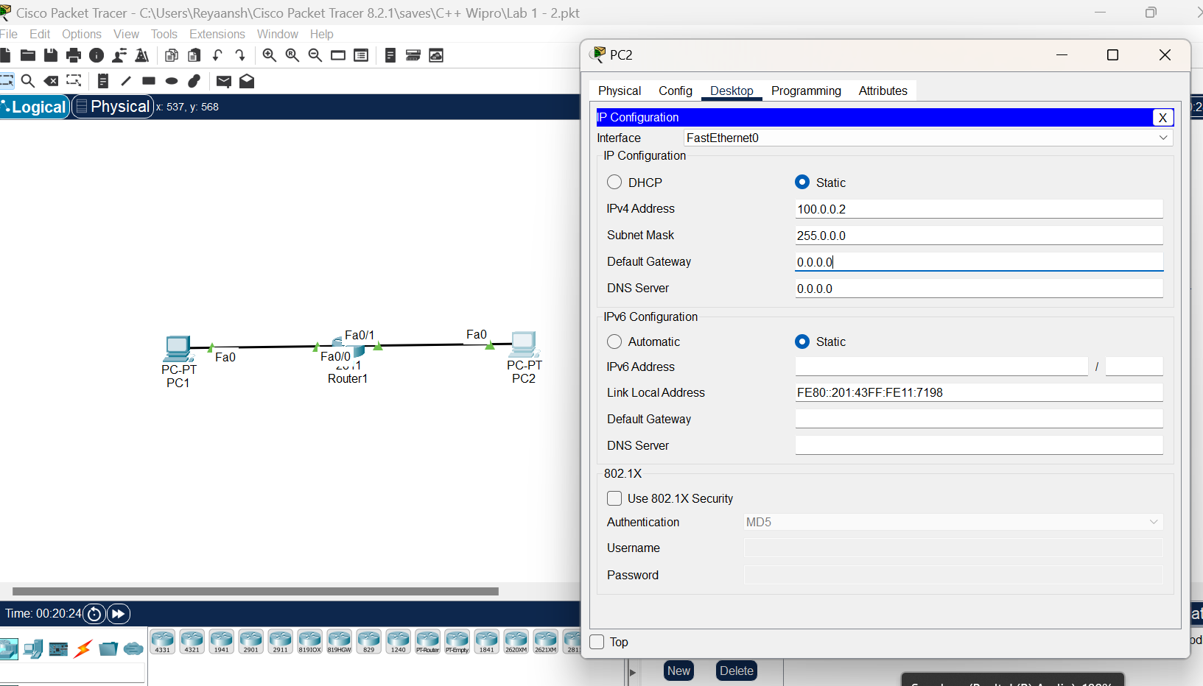

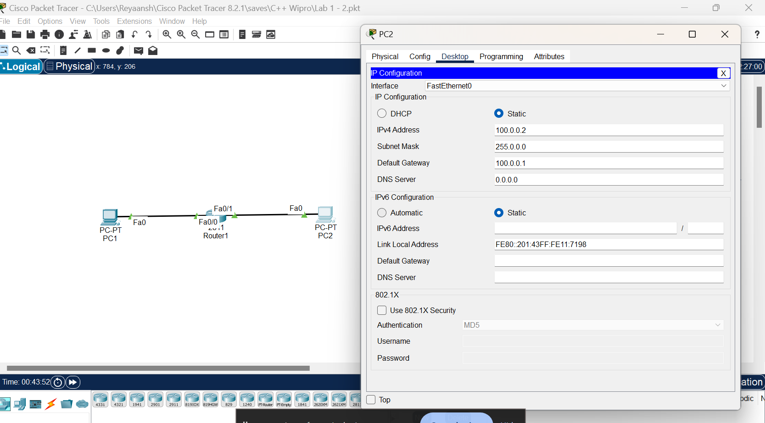

**Day 5**

**Lab 4:**

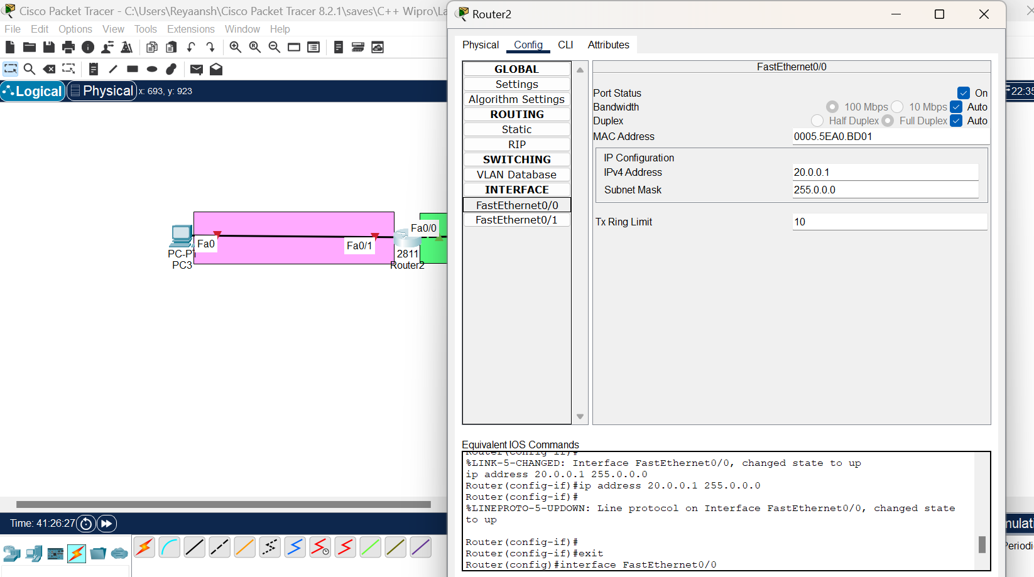

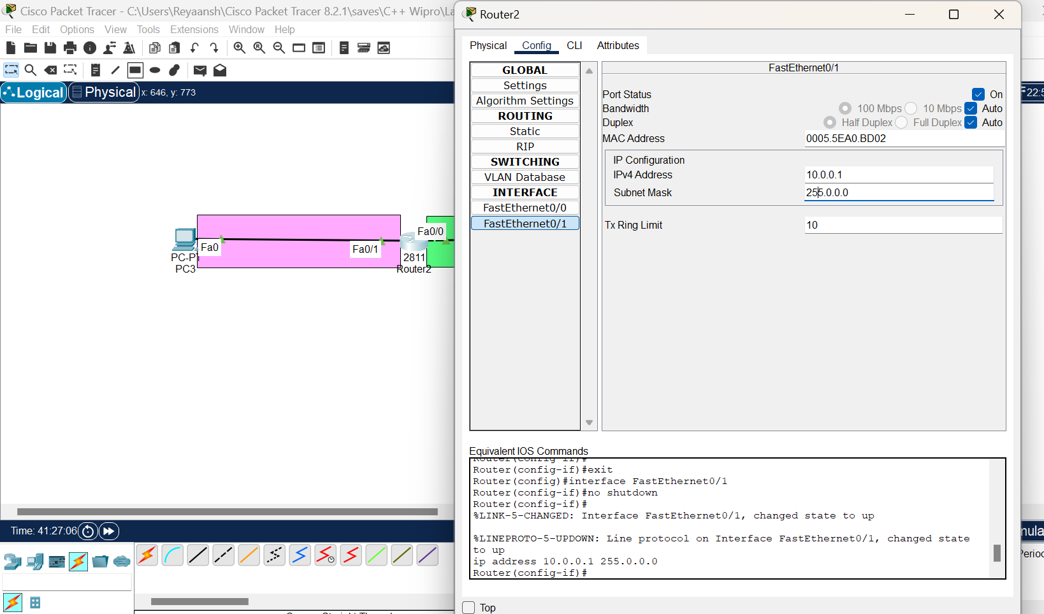

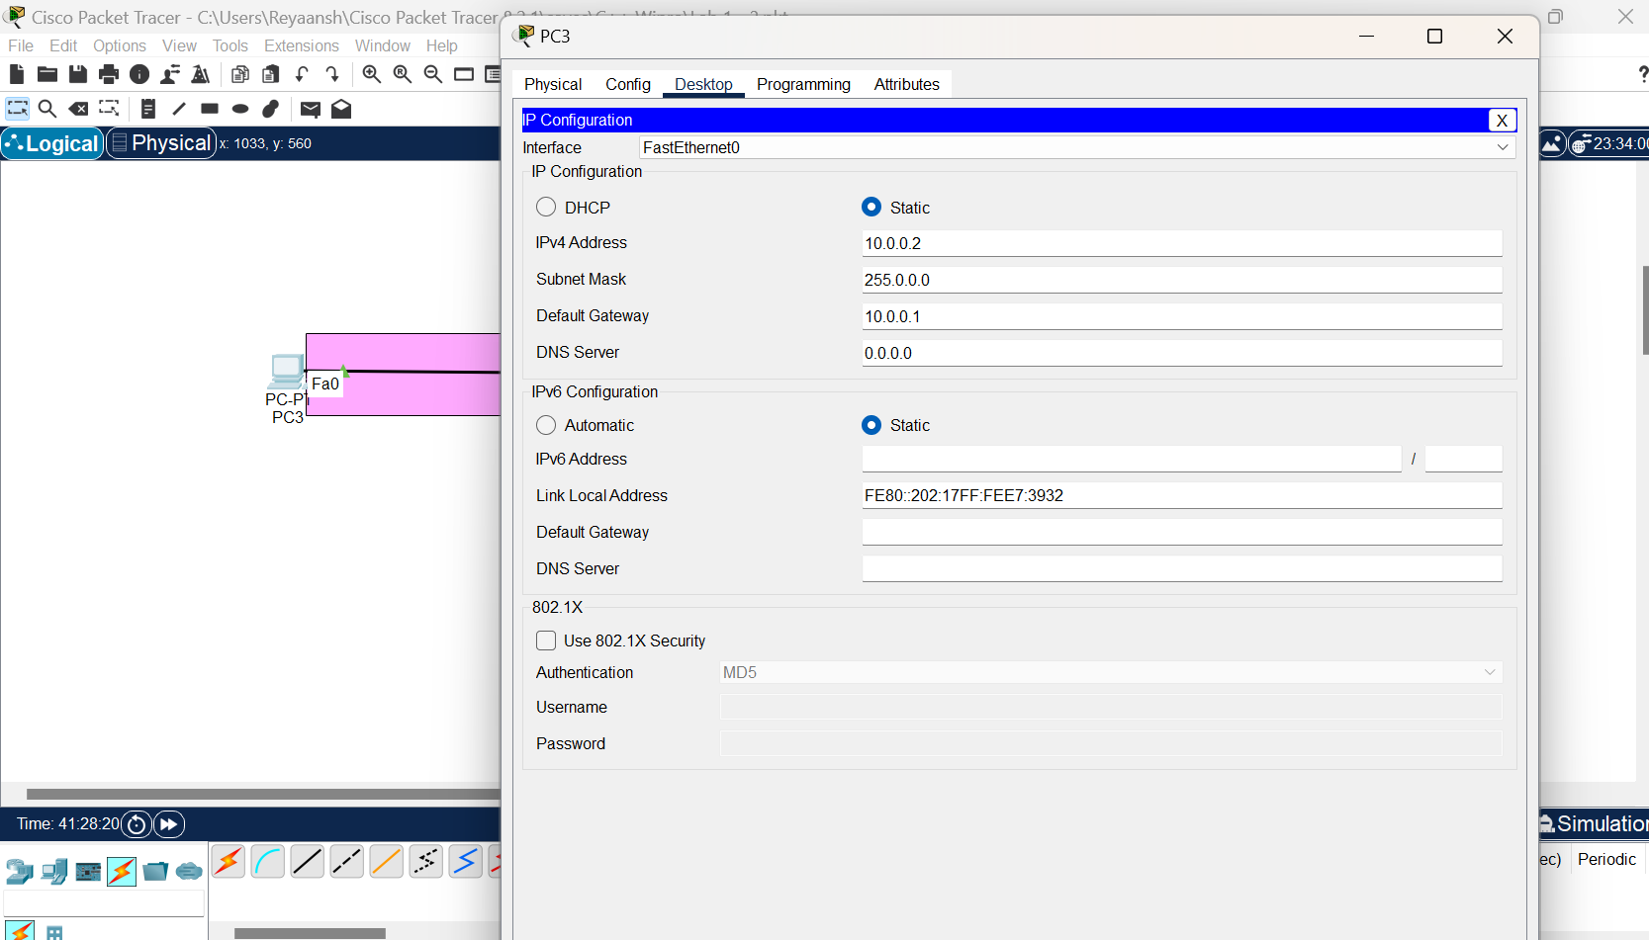

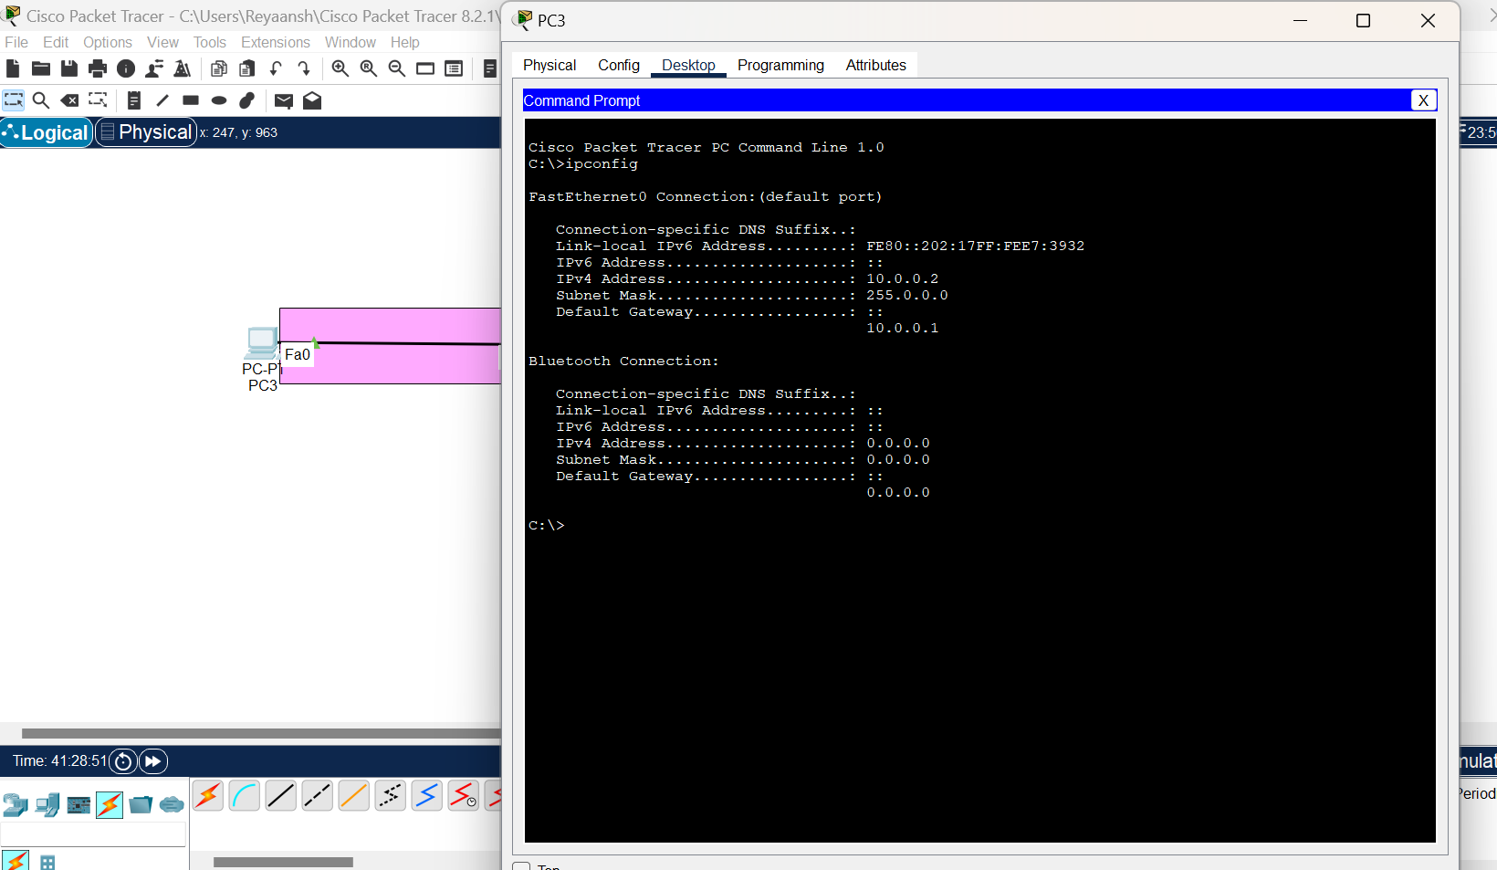

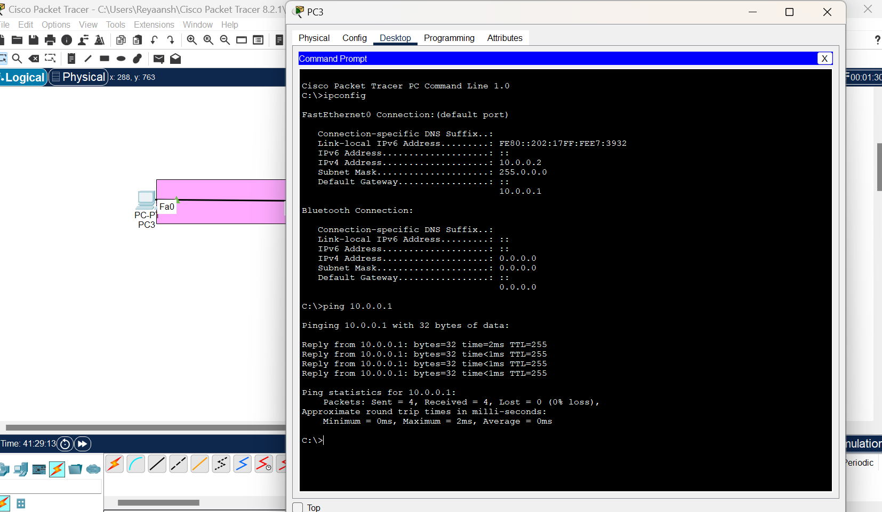

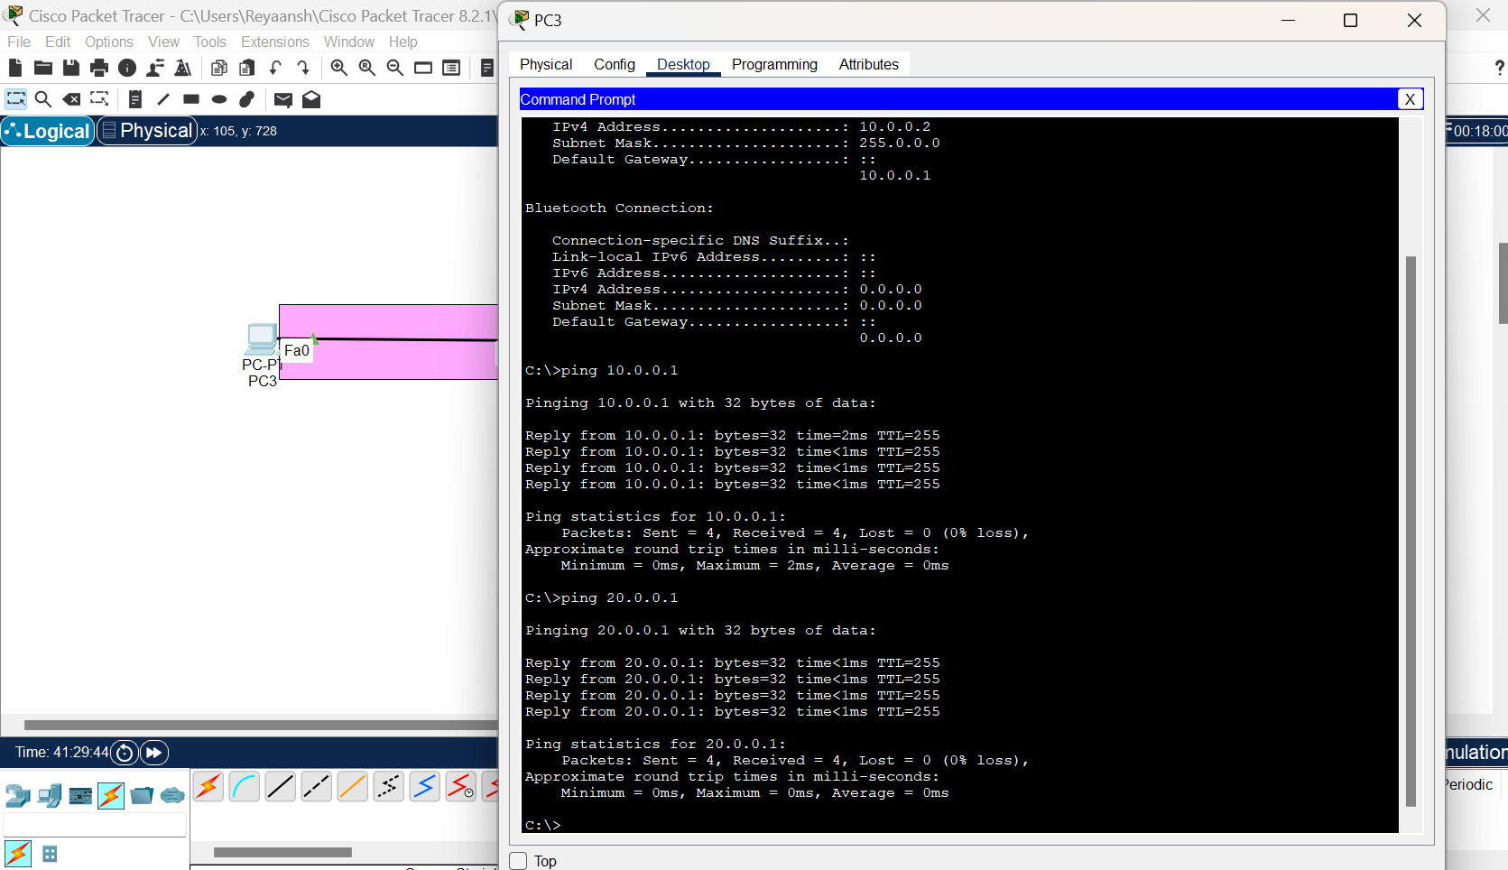

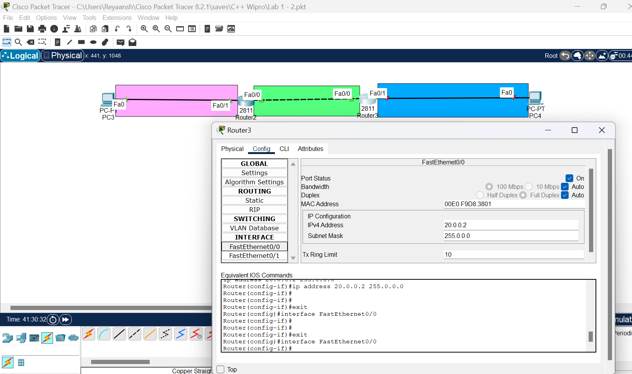

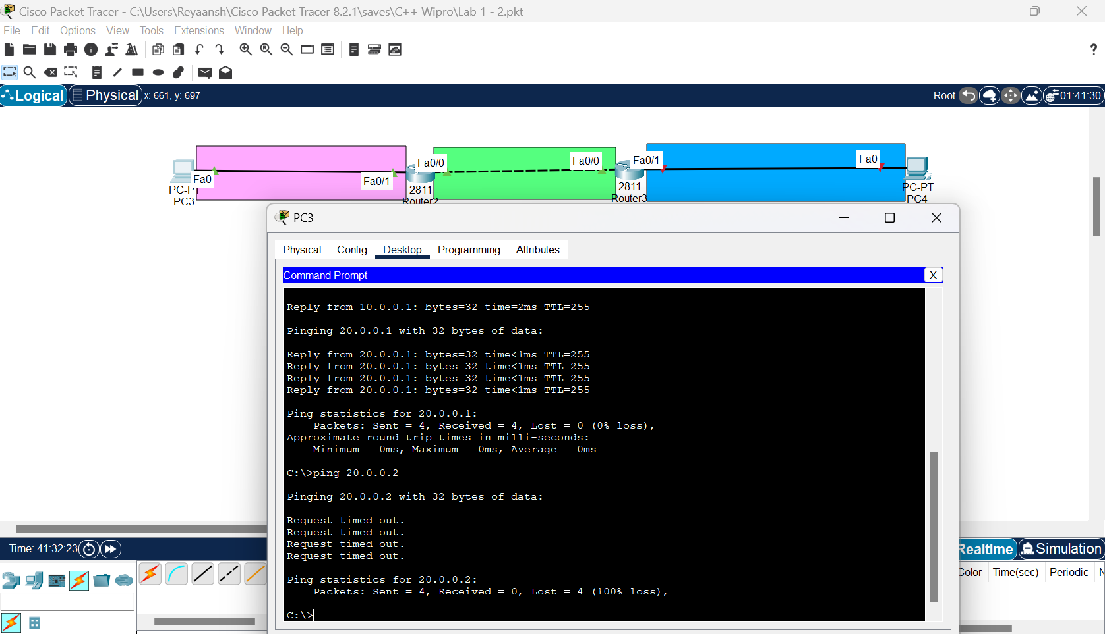

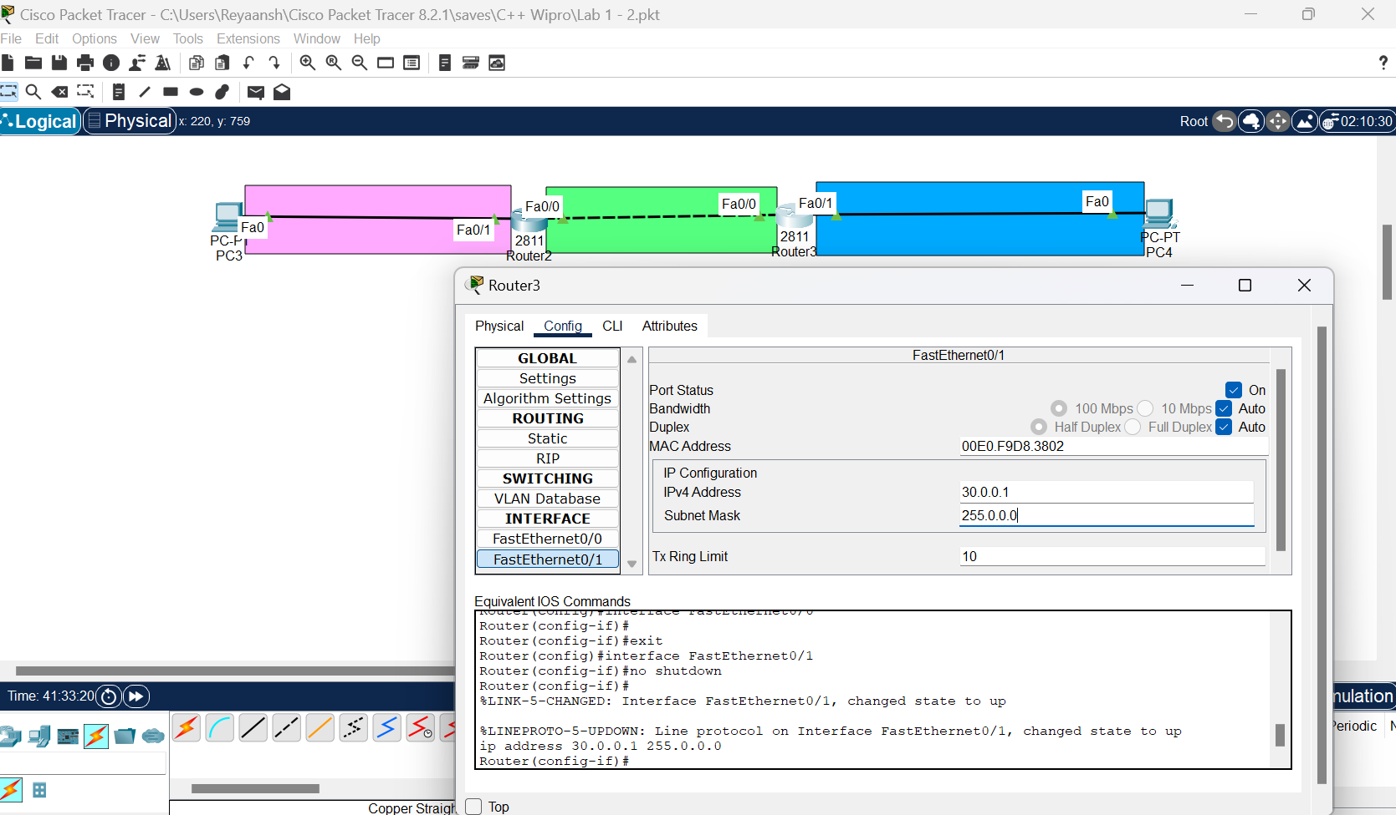

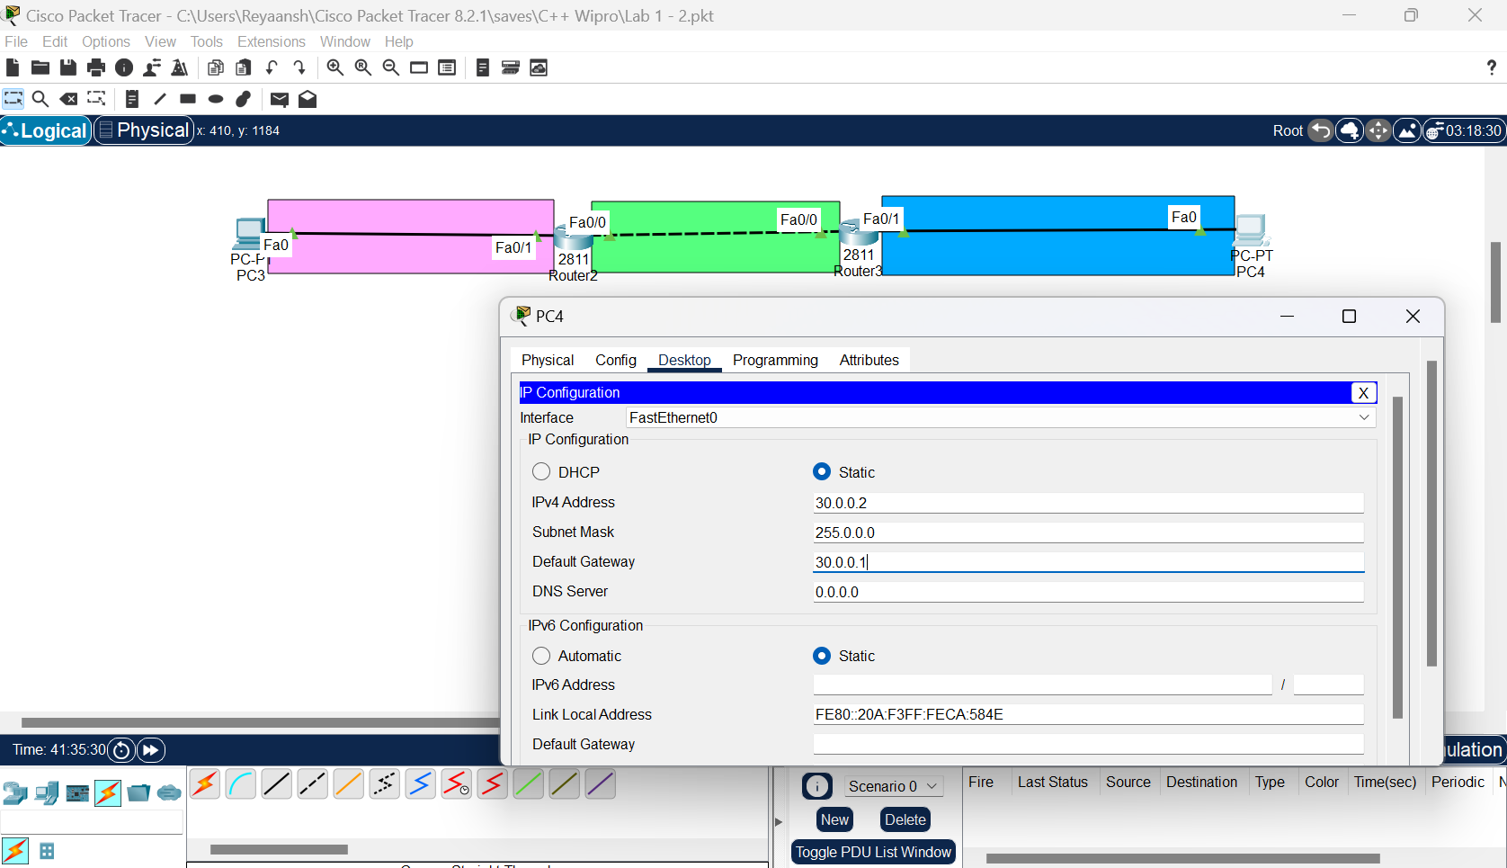

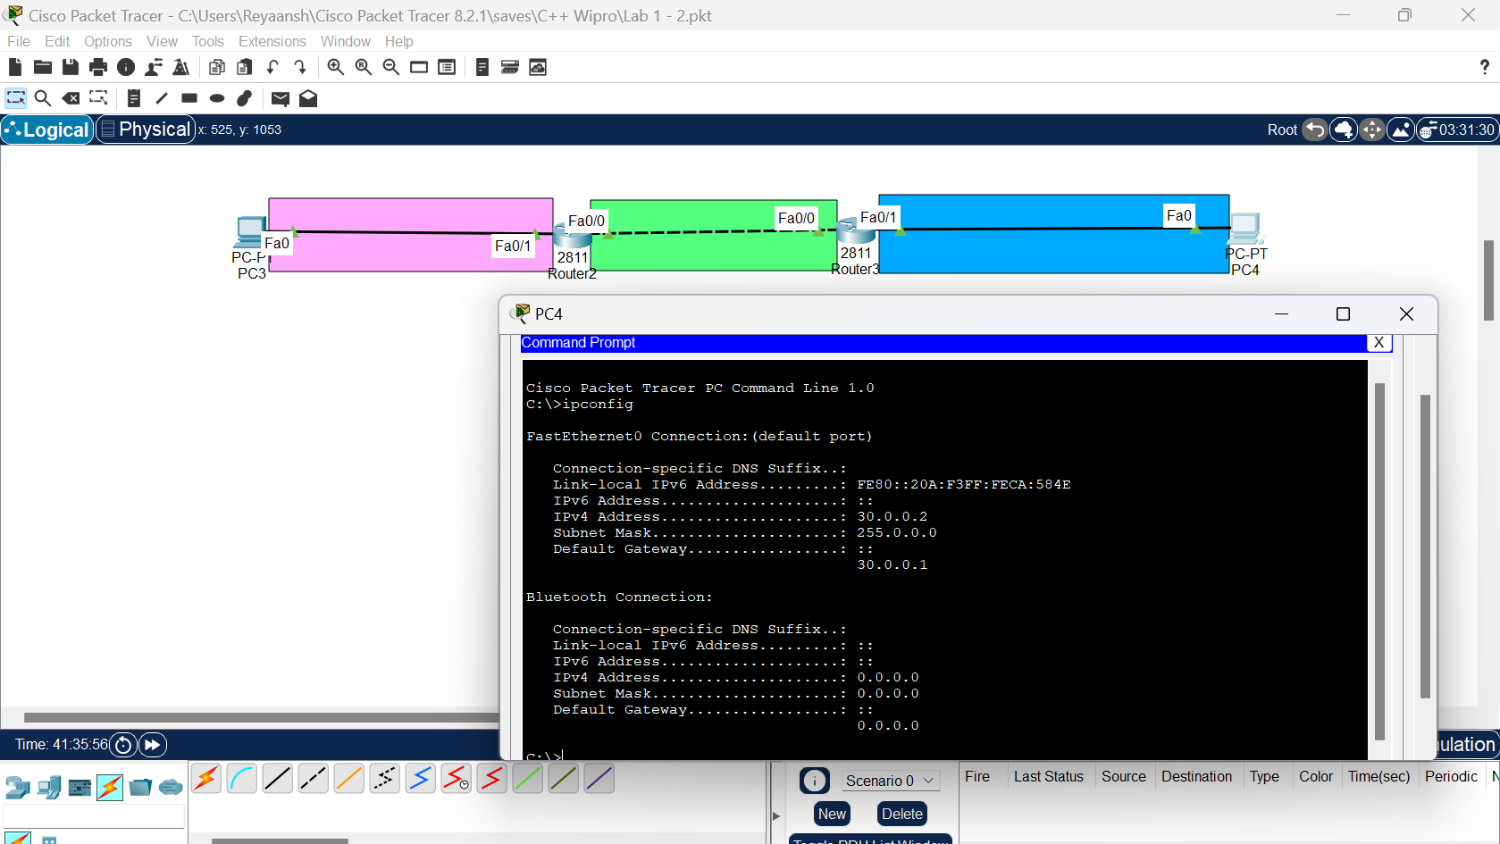

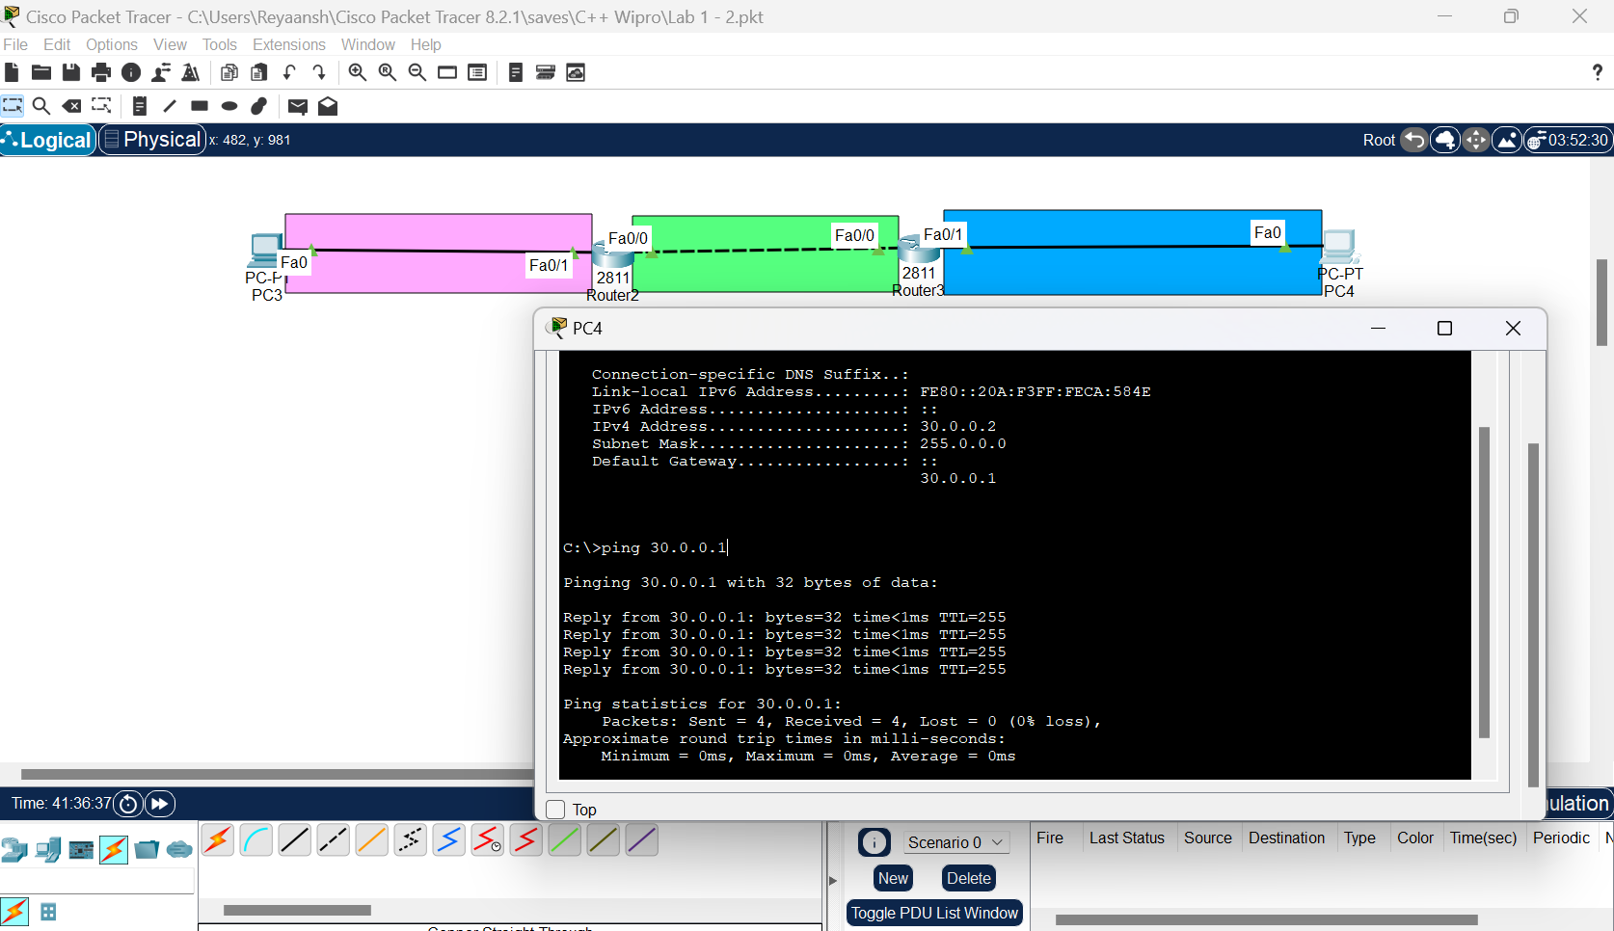

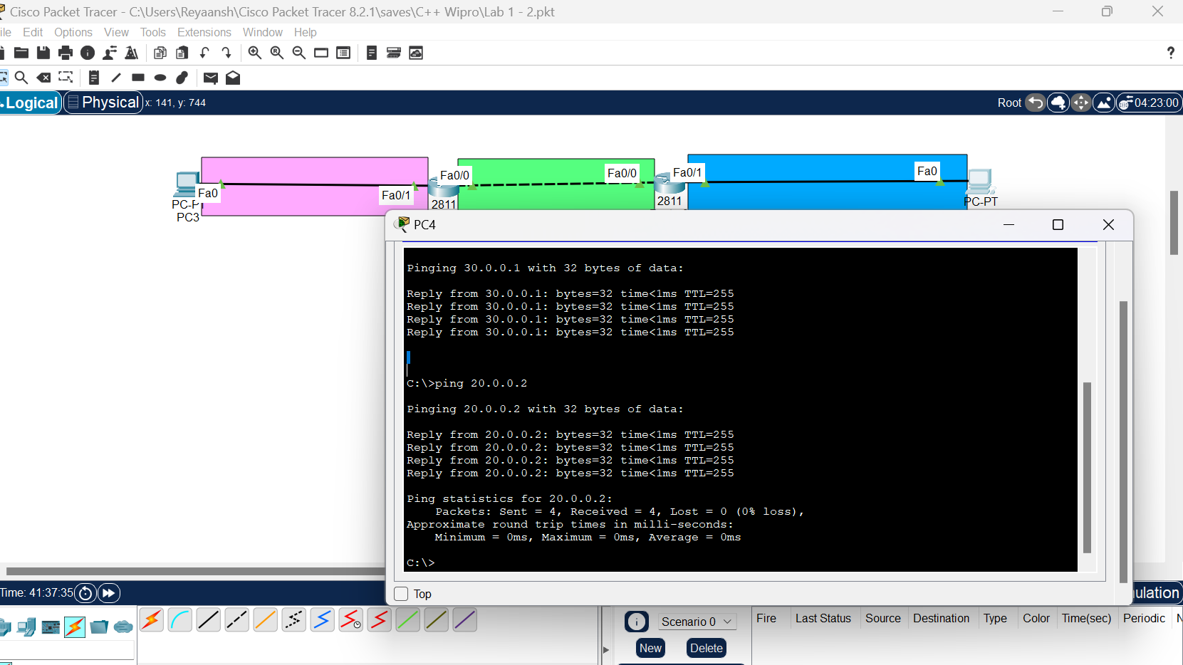

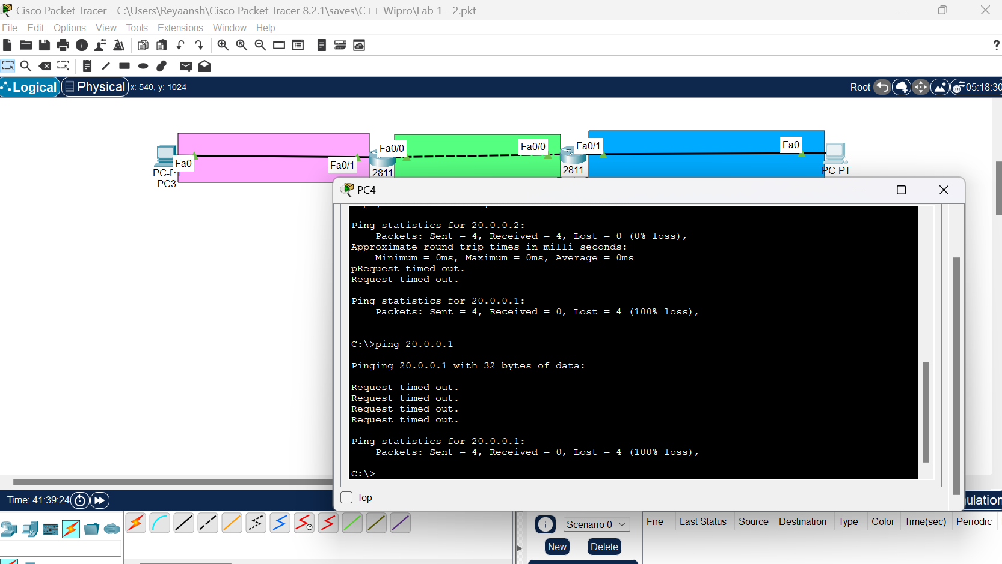

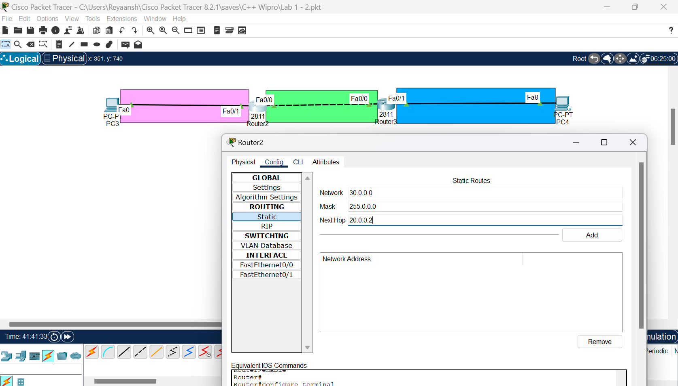

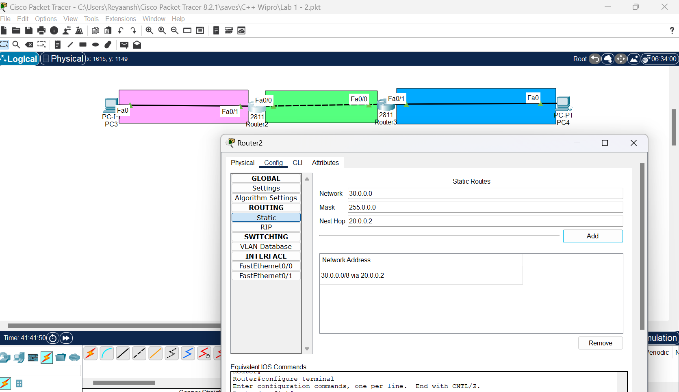

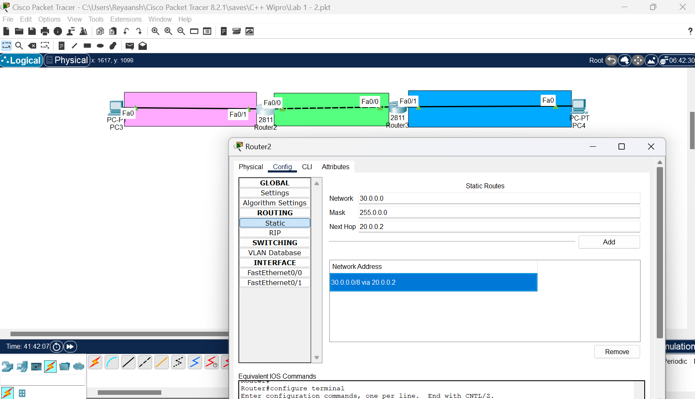

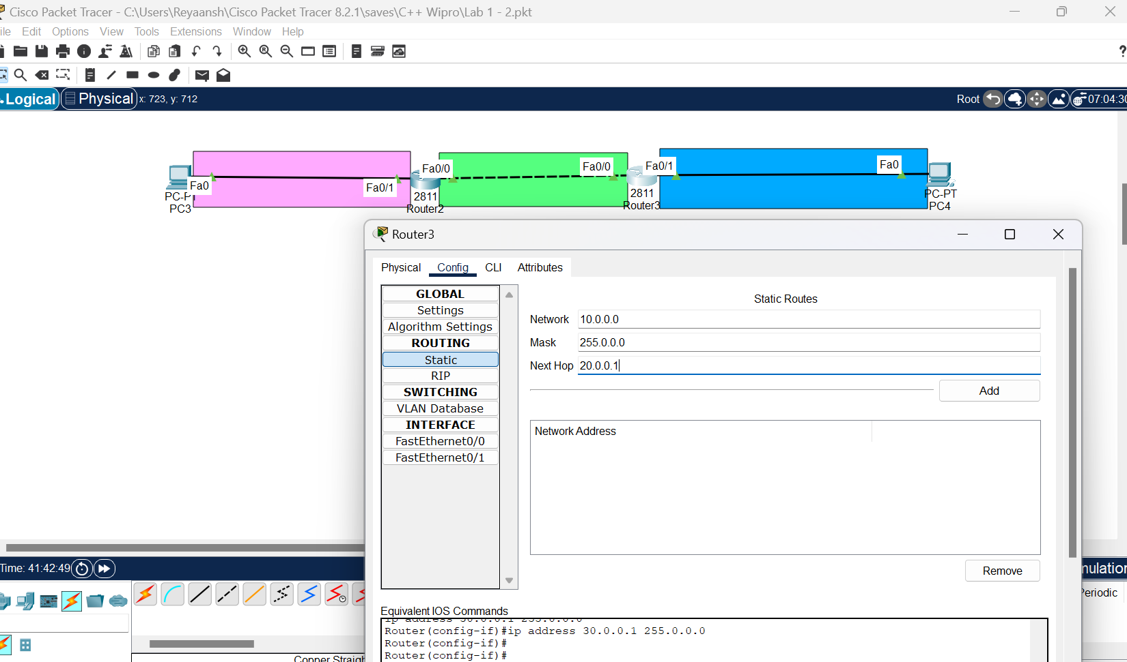

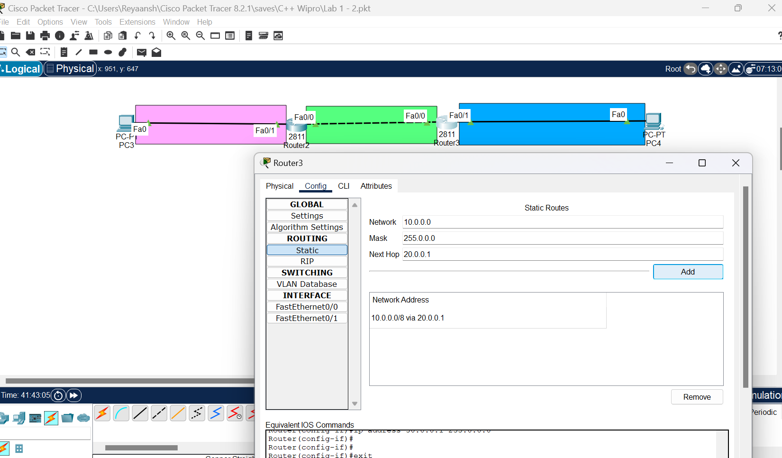

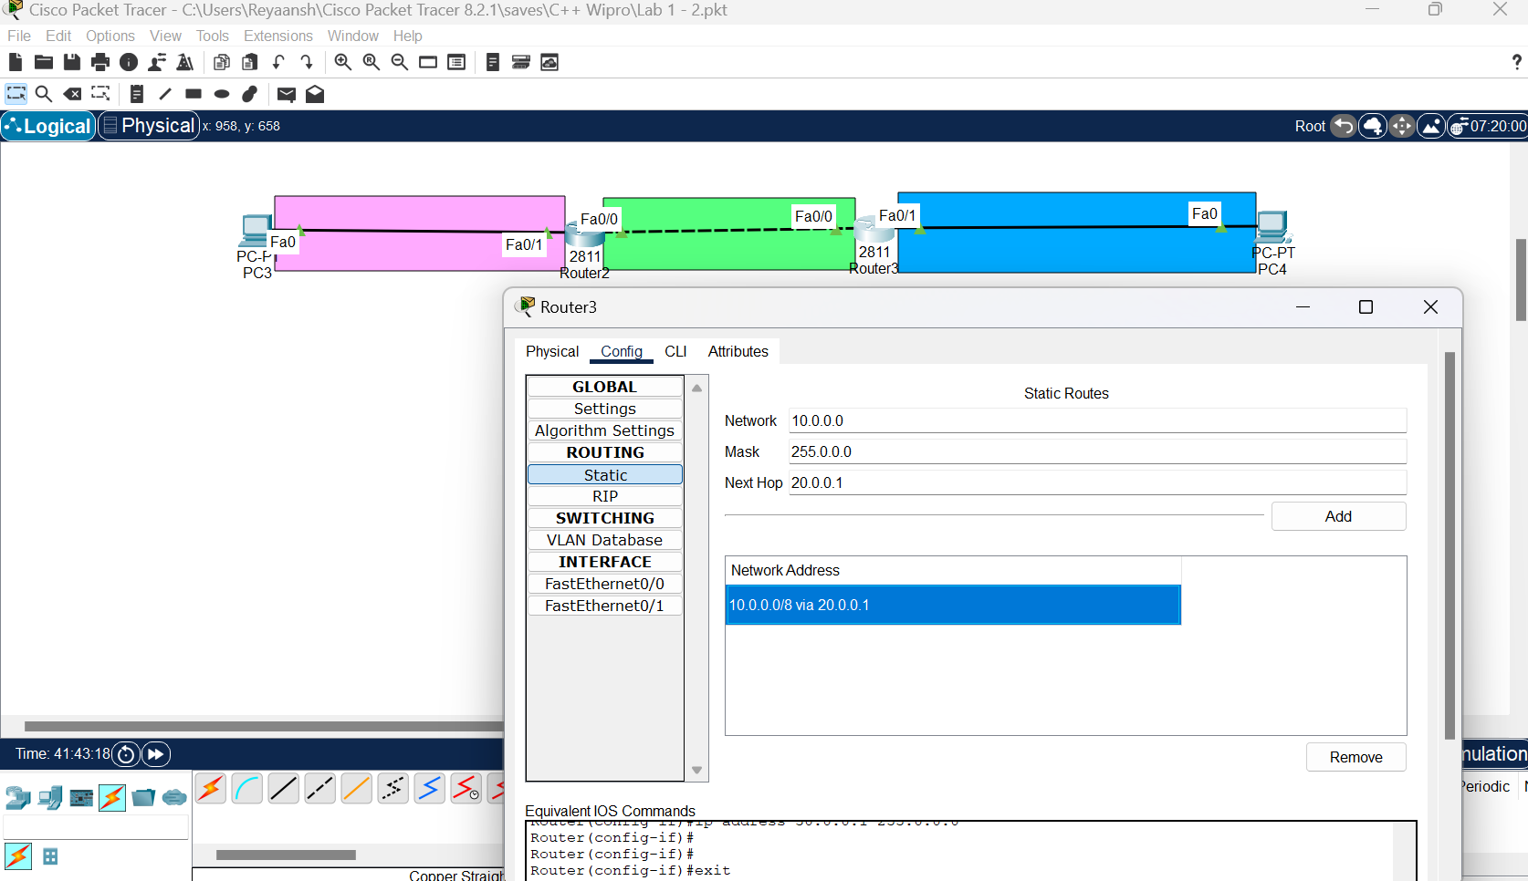

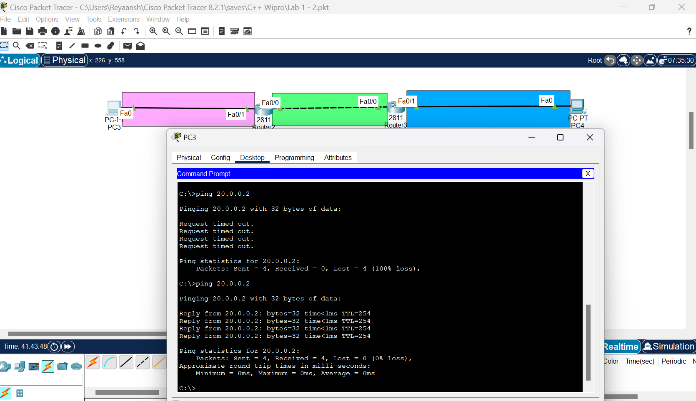

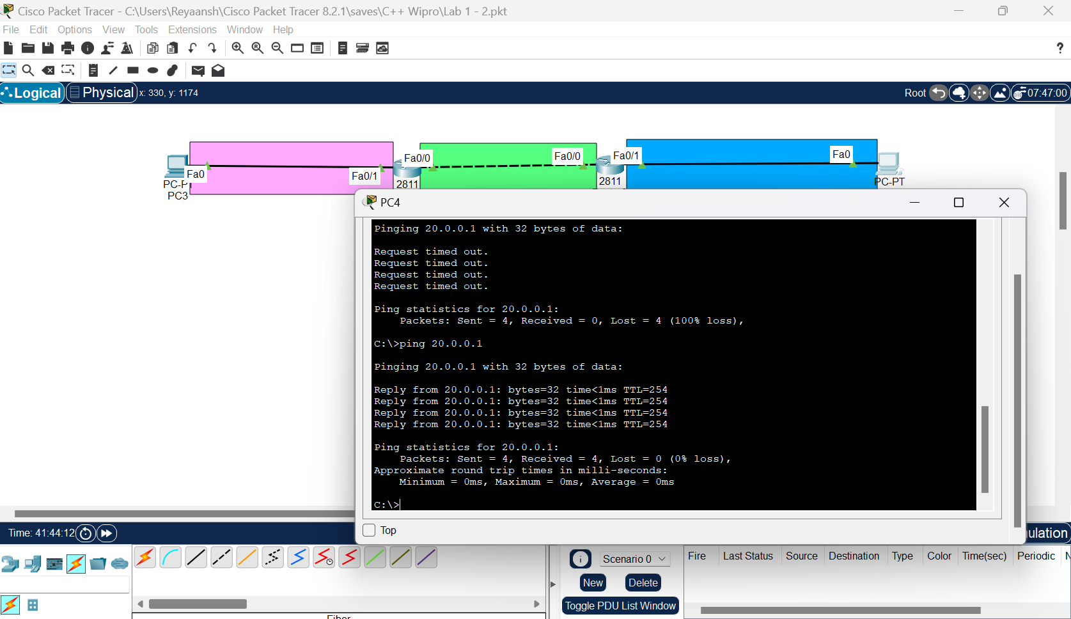

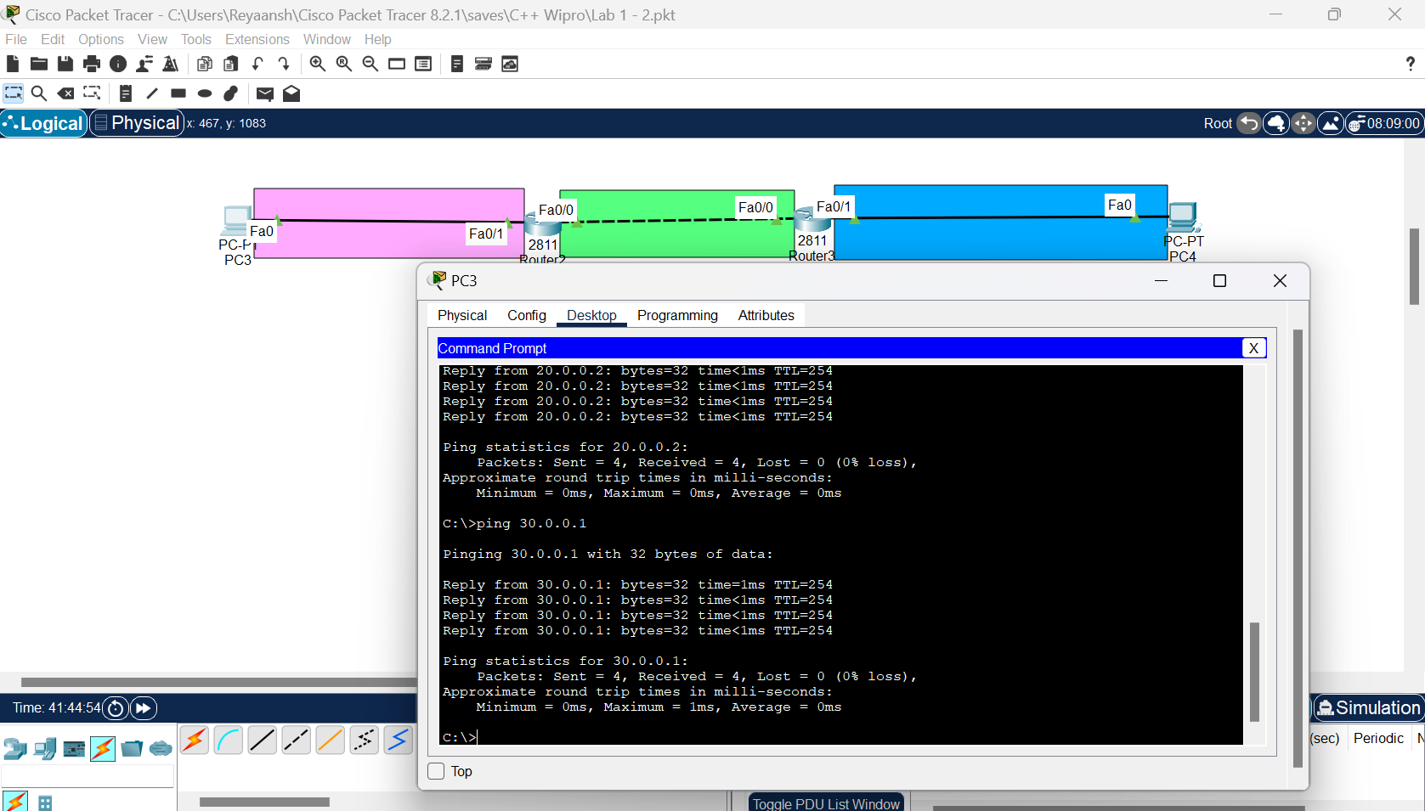

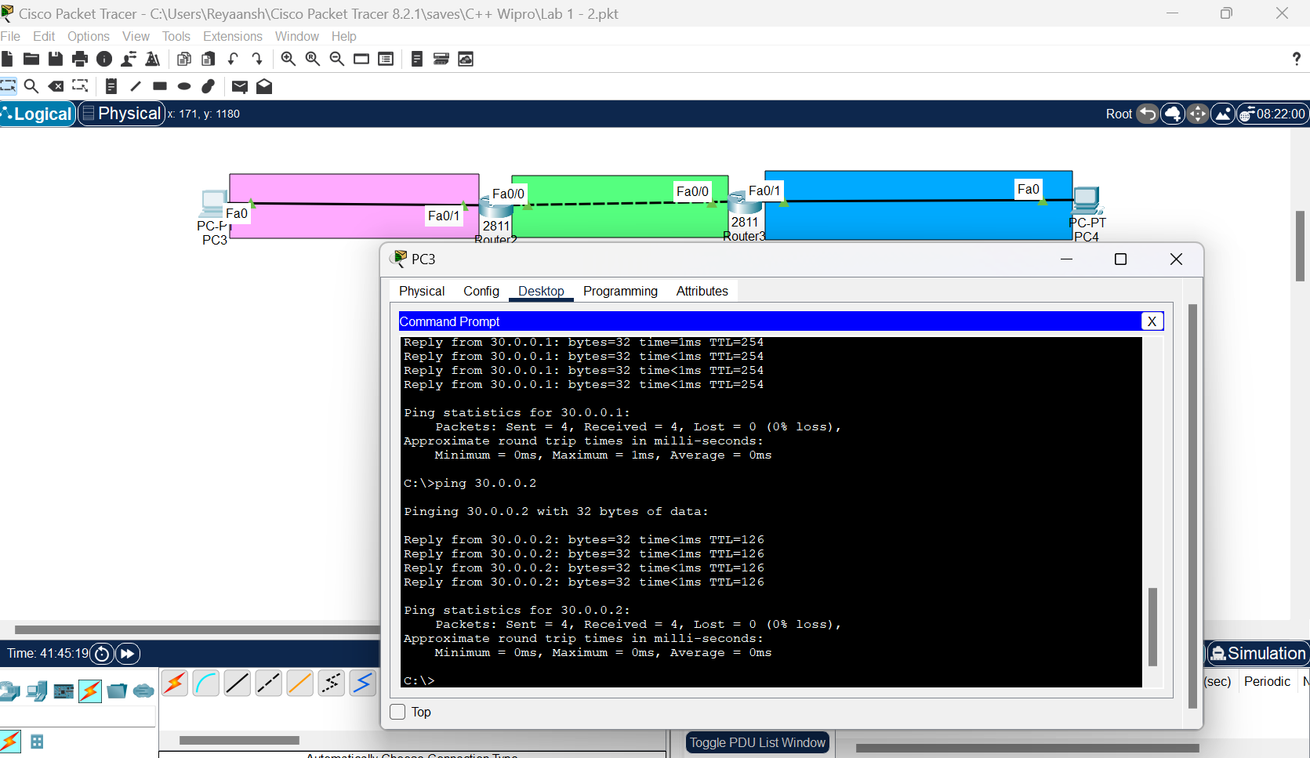

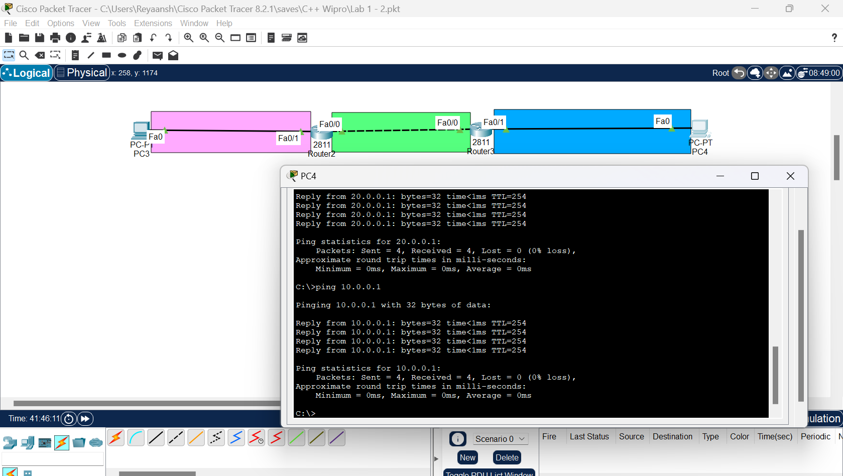

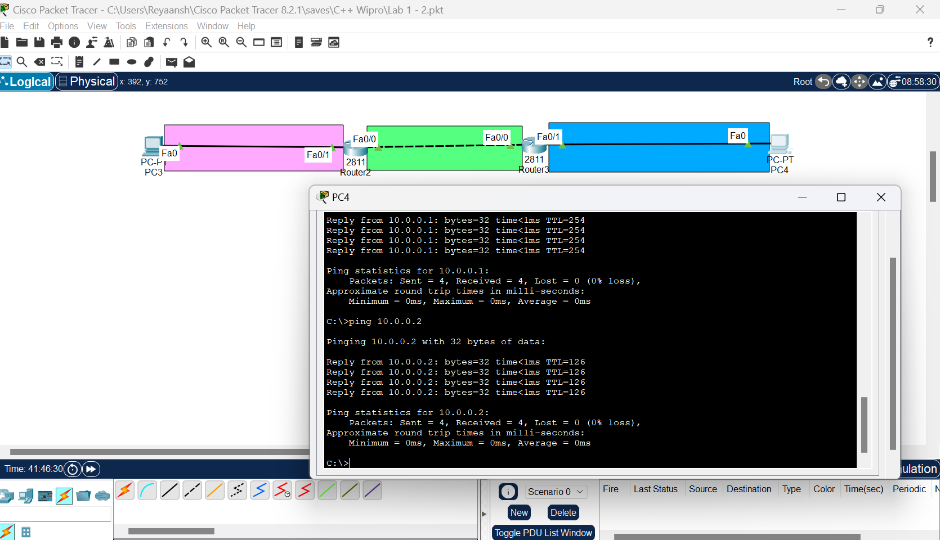

**Day 5:**

Lab 5 : Static Routing (on three routers)

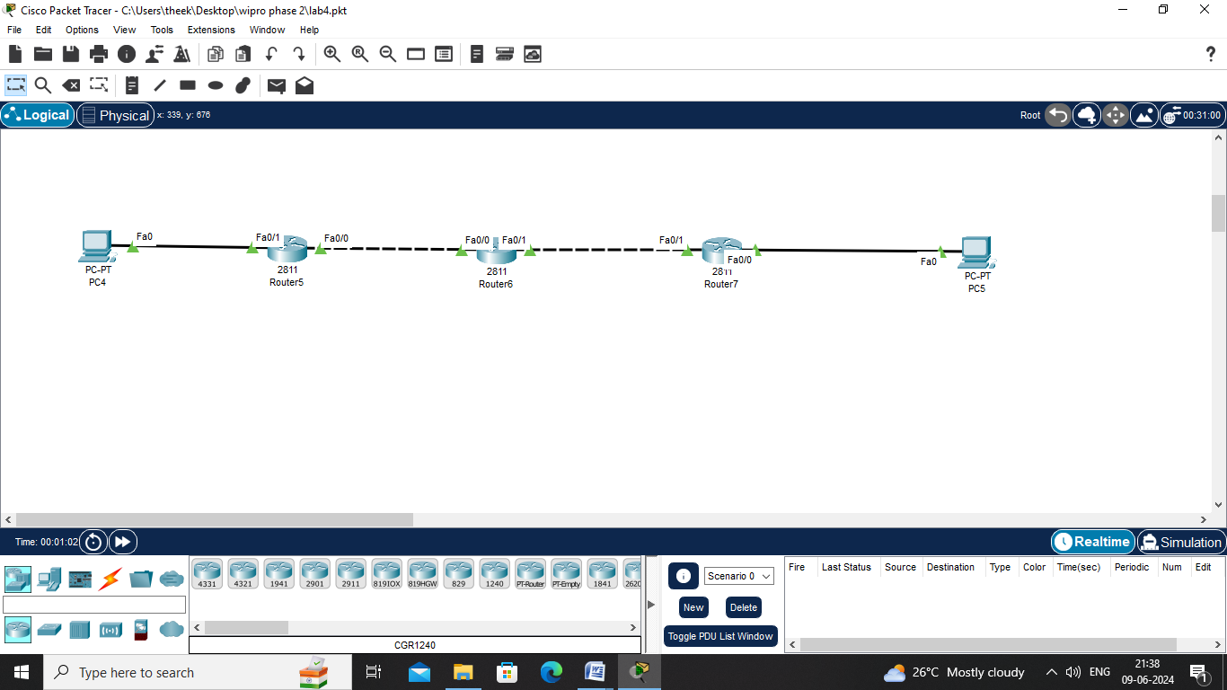

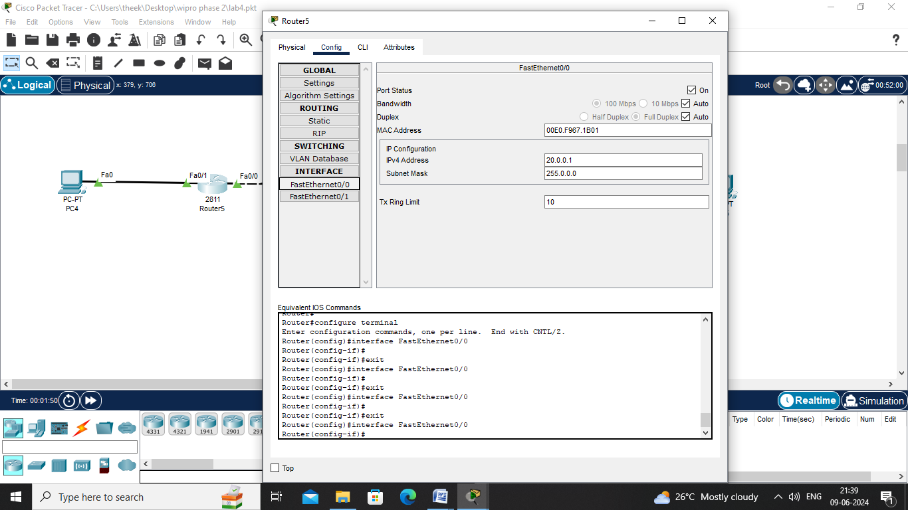

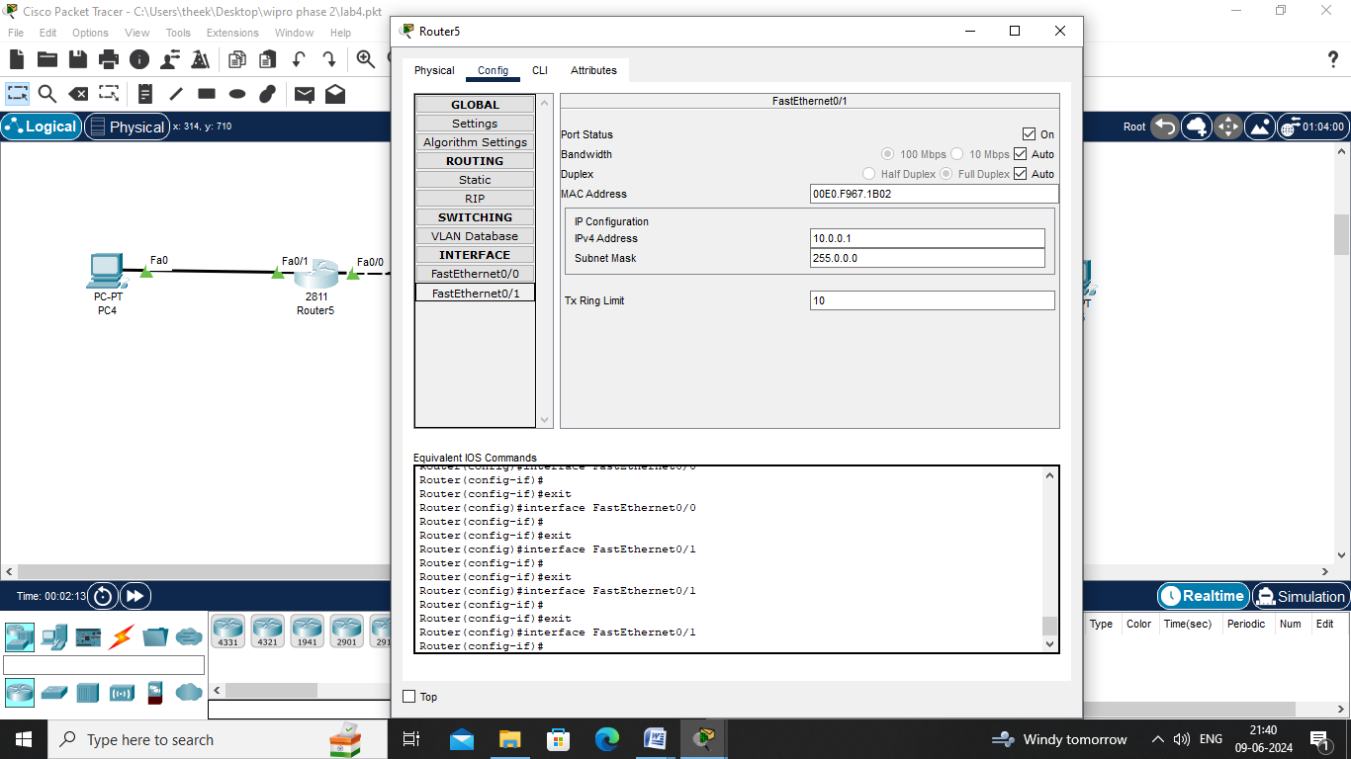

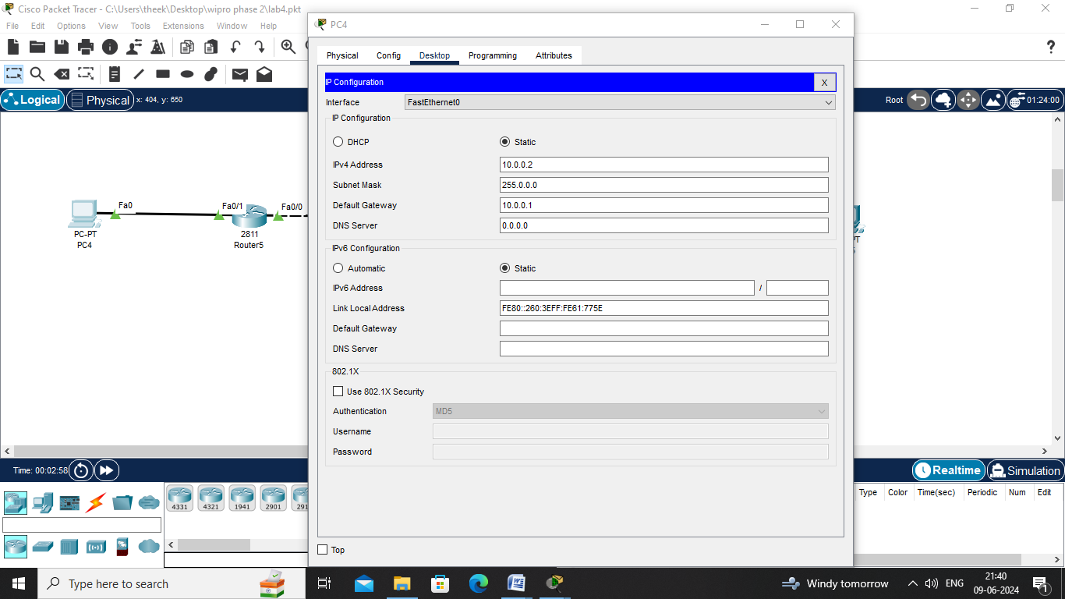

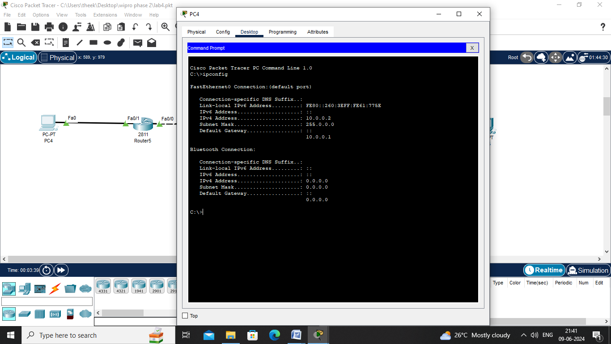

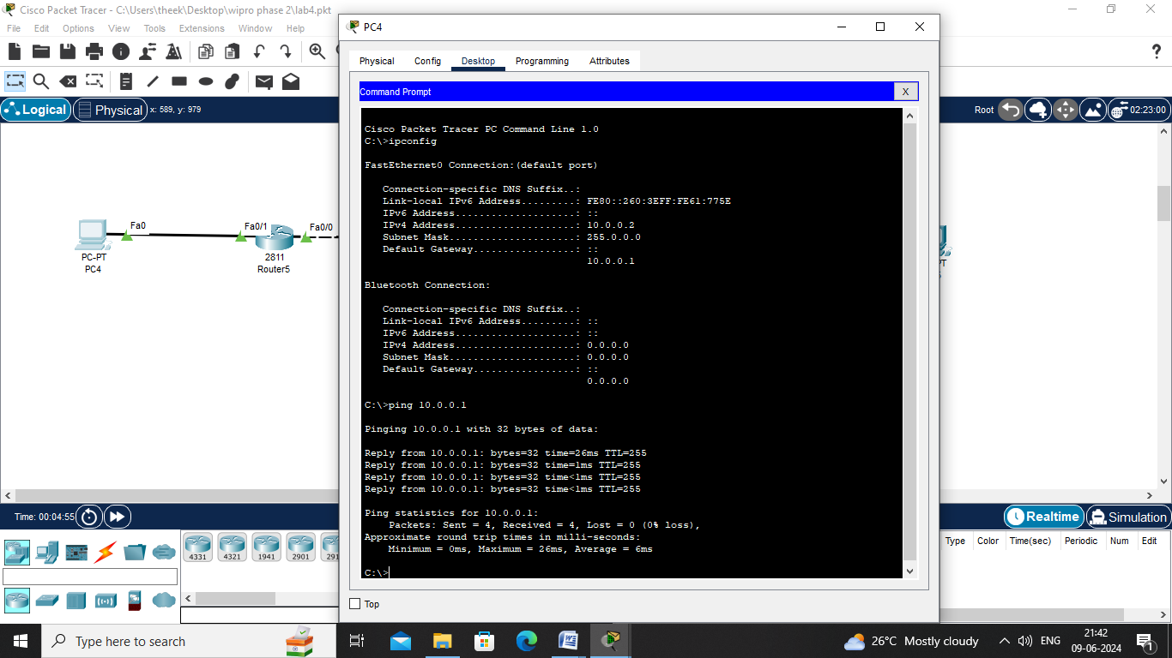

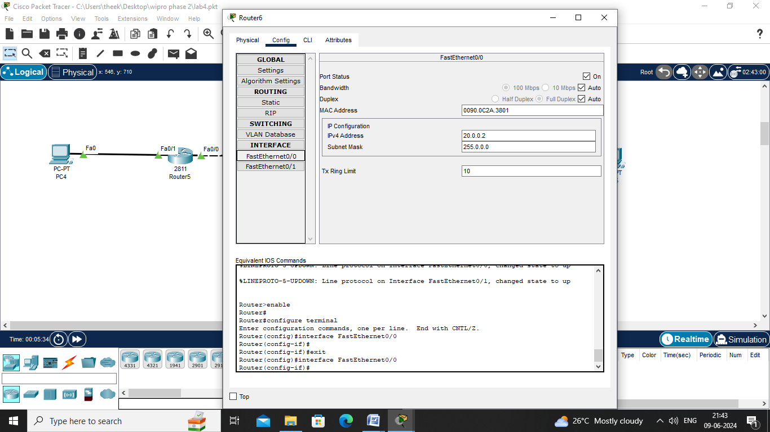

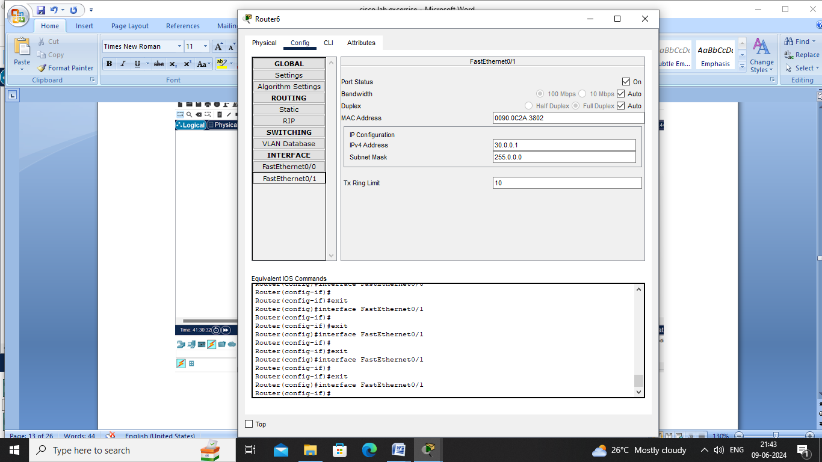

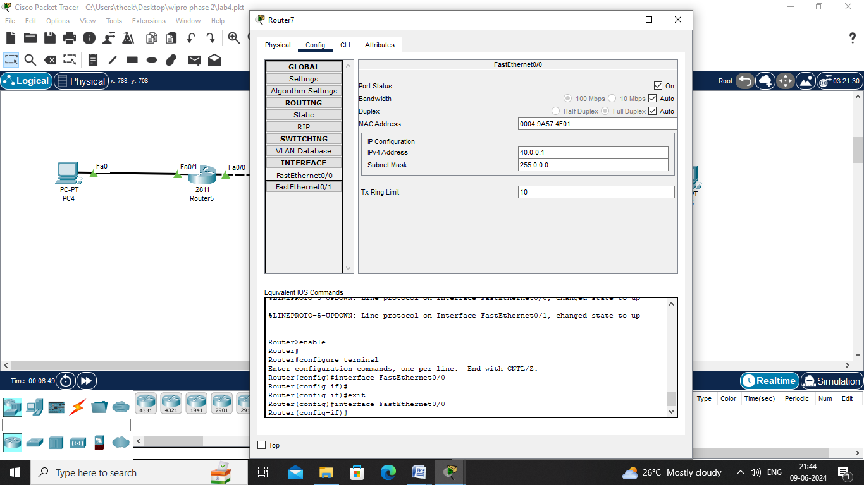

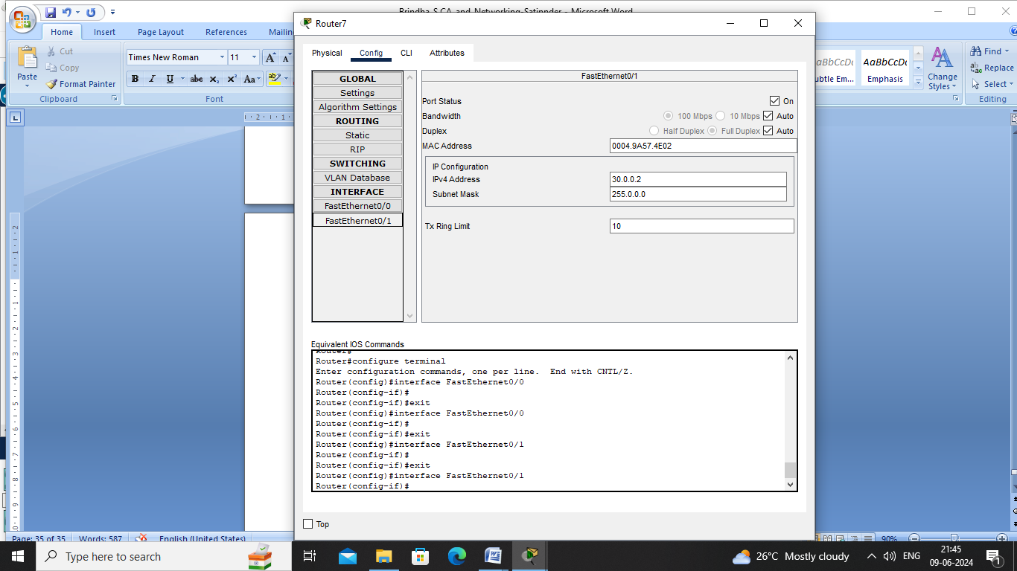

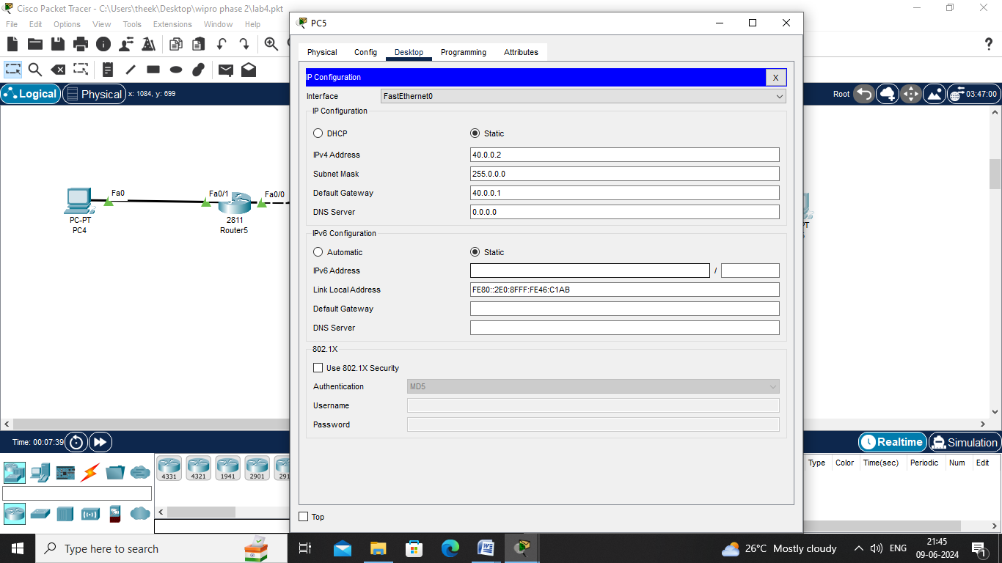

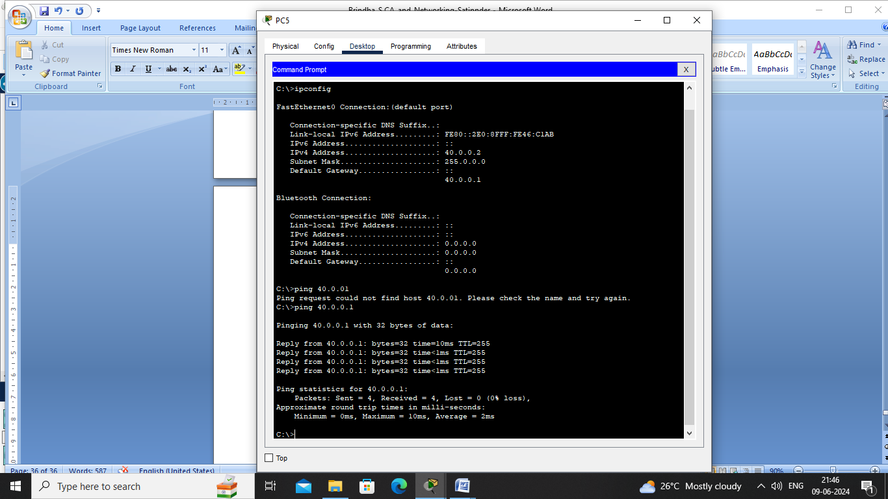

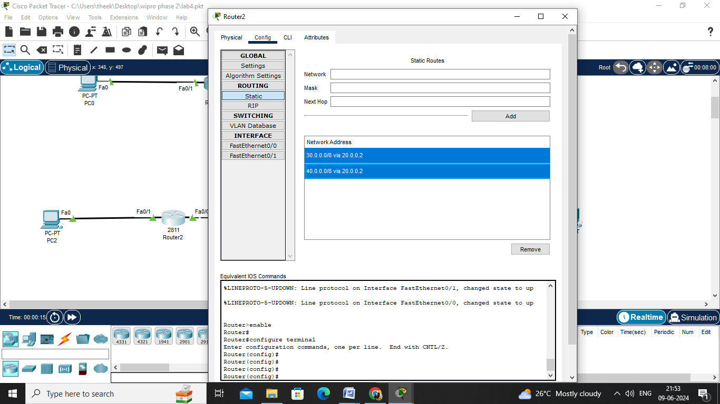

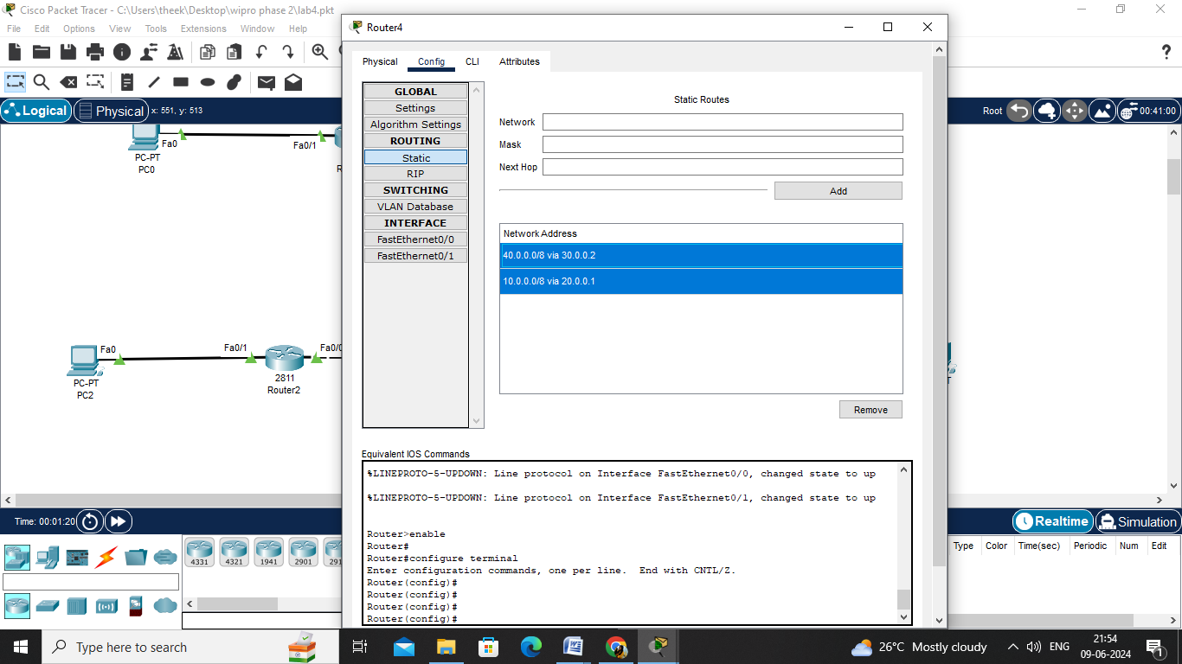

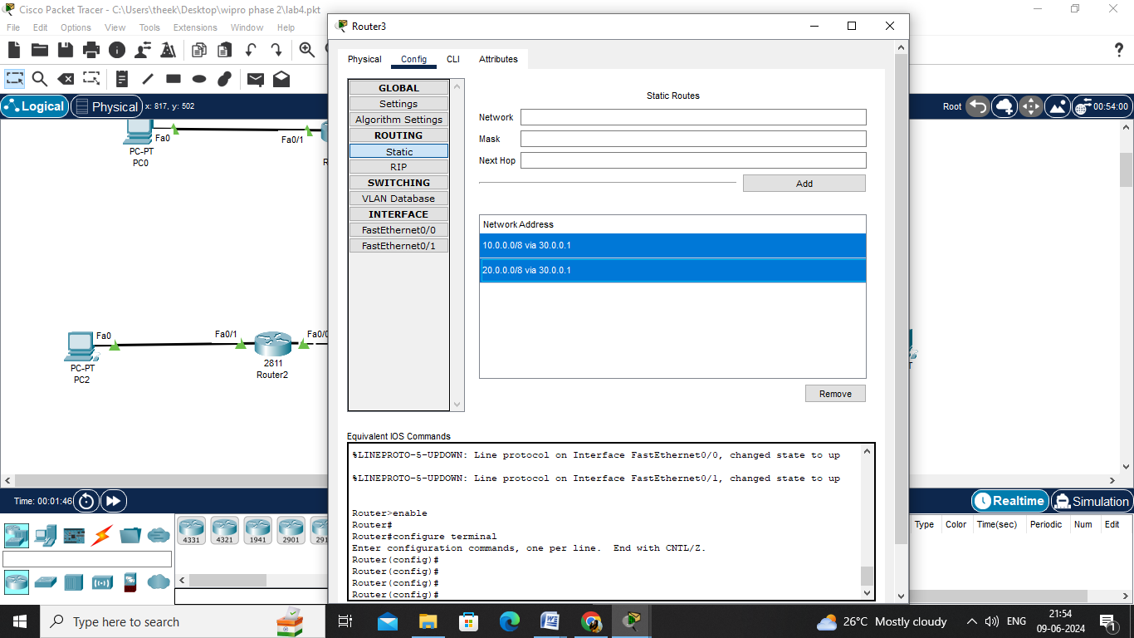

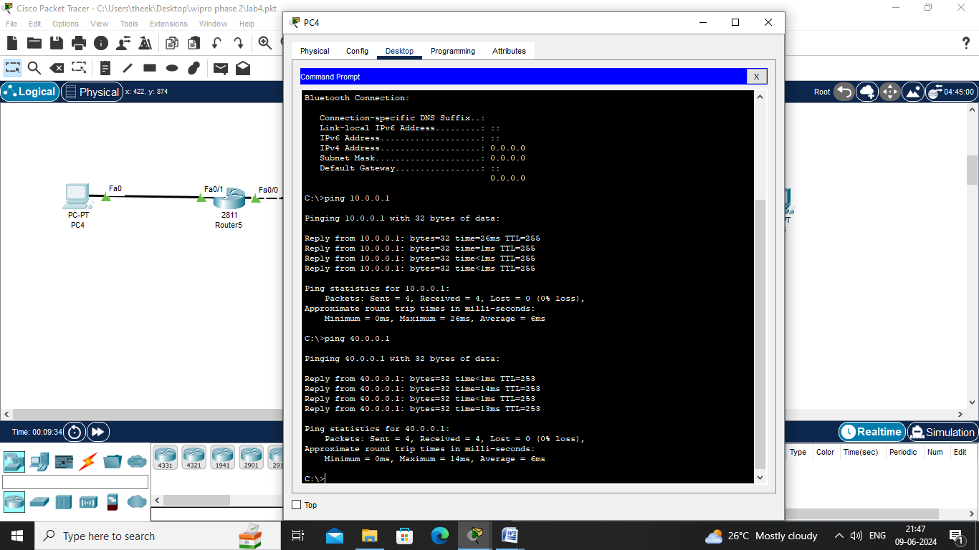

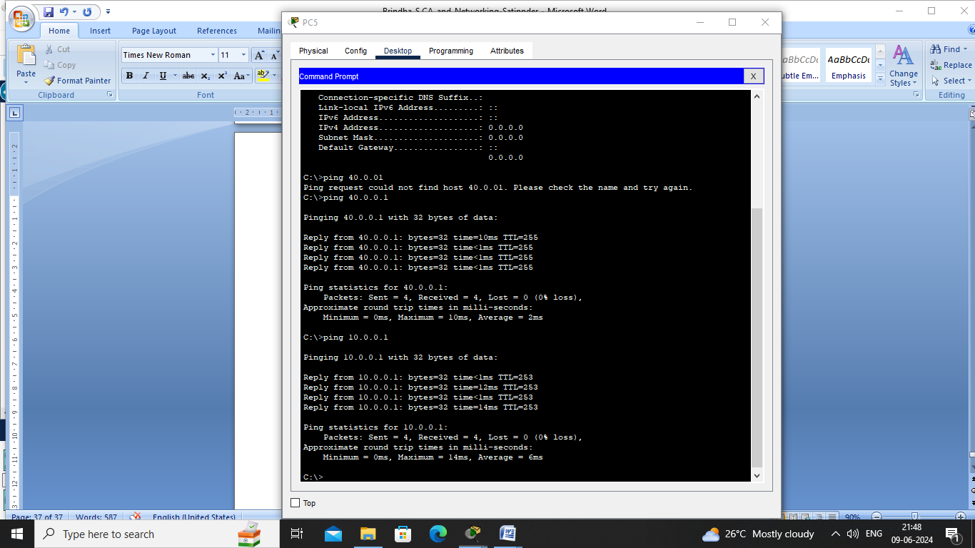

Lab 6 : Dynamic Routing (on three routers)

























